Report IMPROVED

Mobile Research Infrastructure Experiments

Case study at Dow Terneuzen



Ghent University - Faculty of Bio-science Engineering

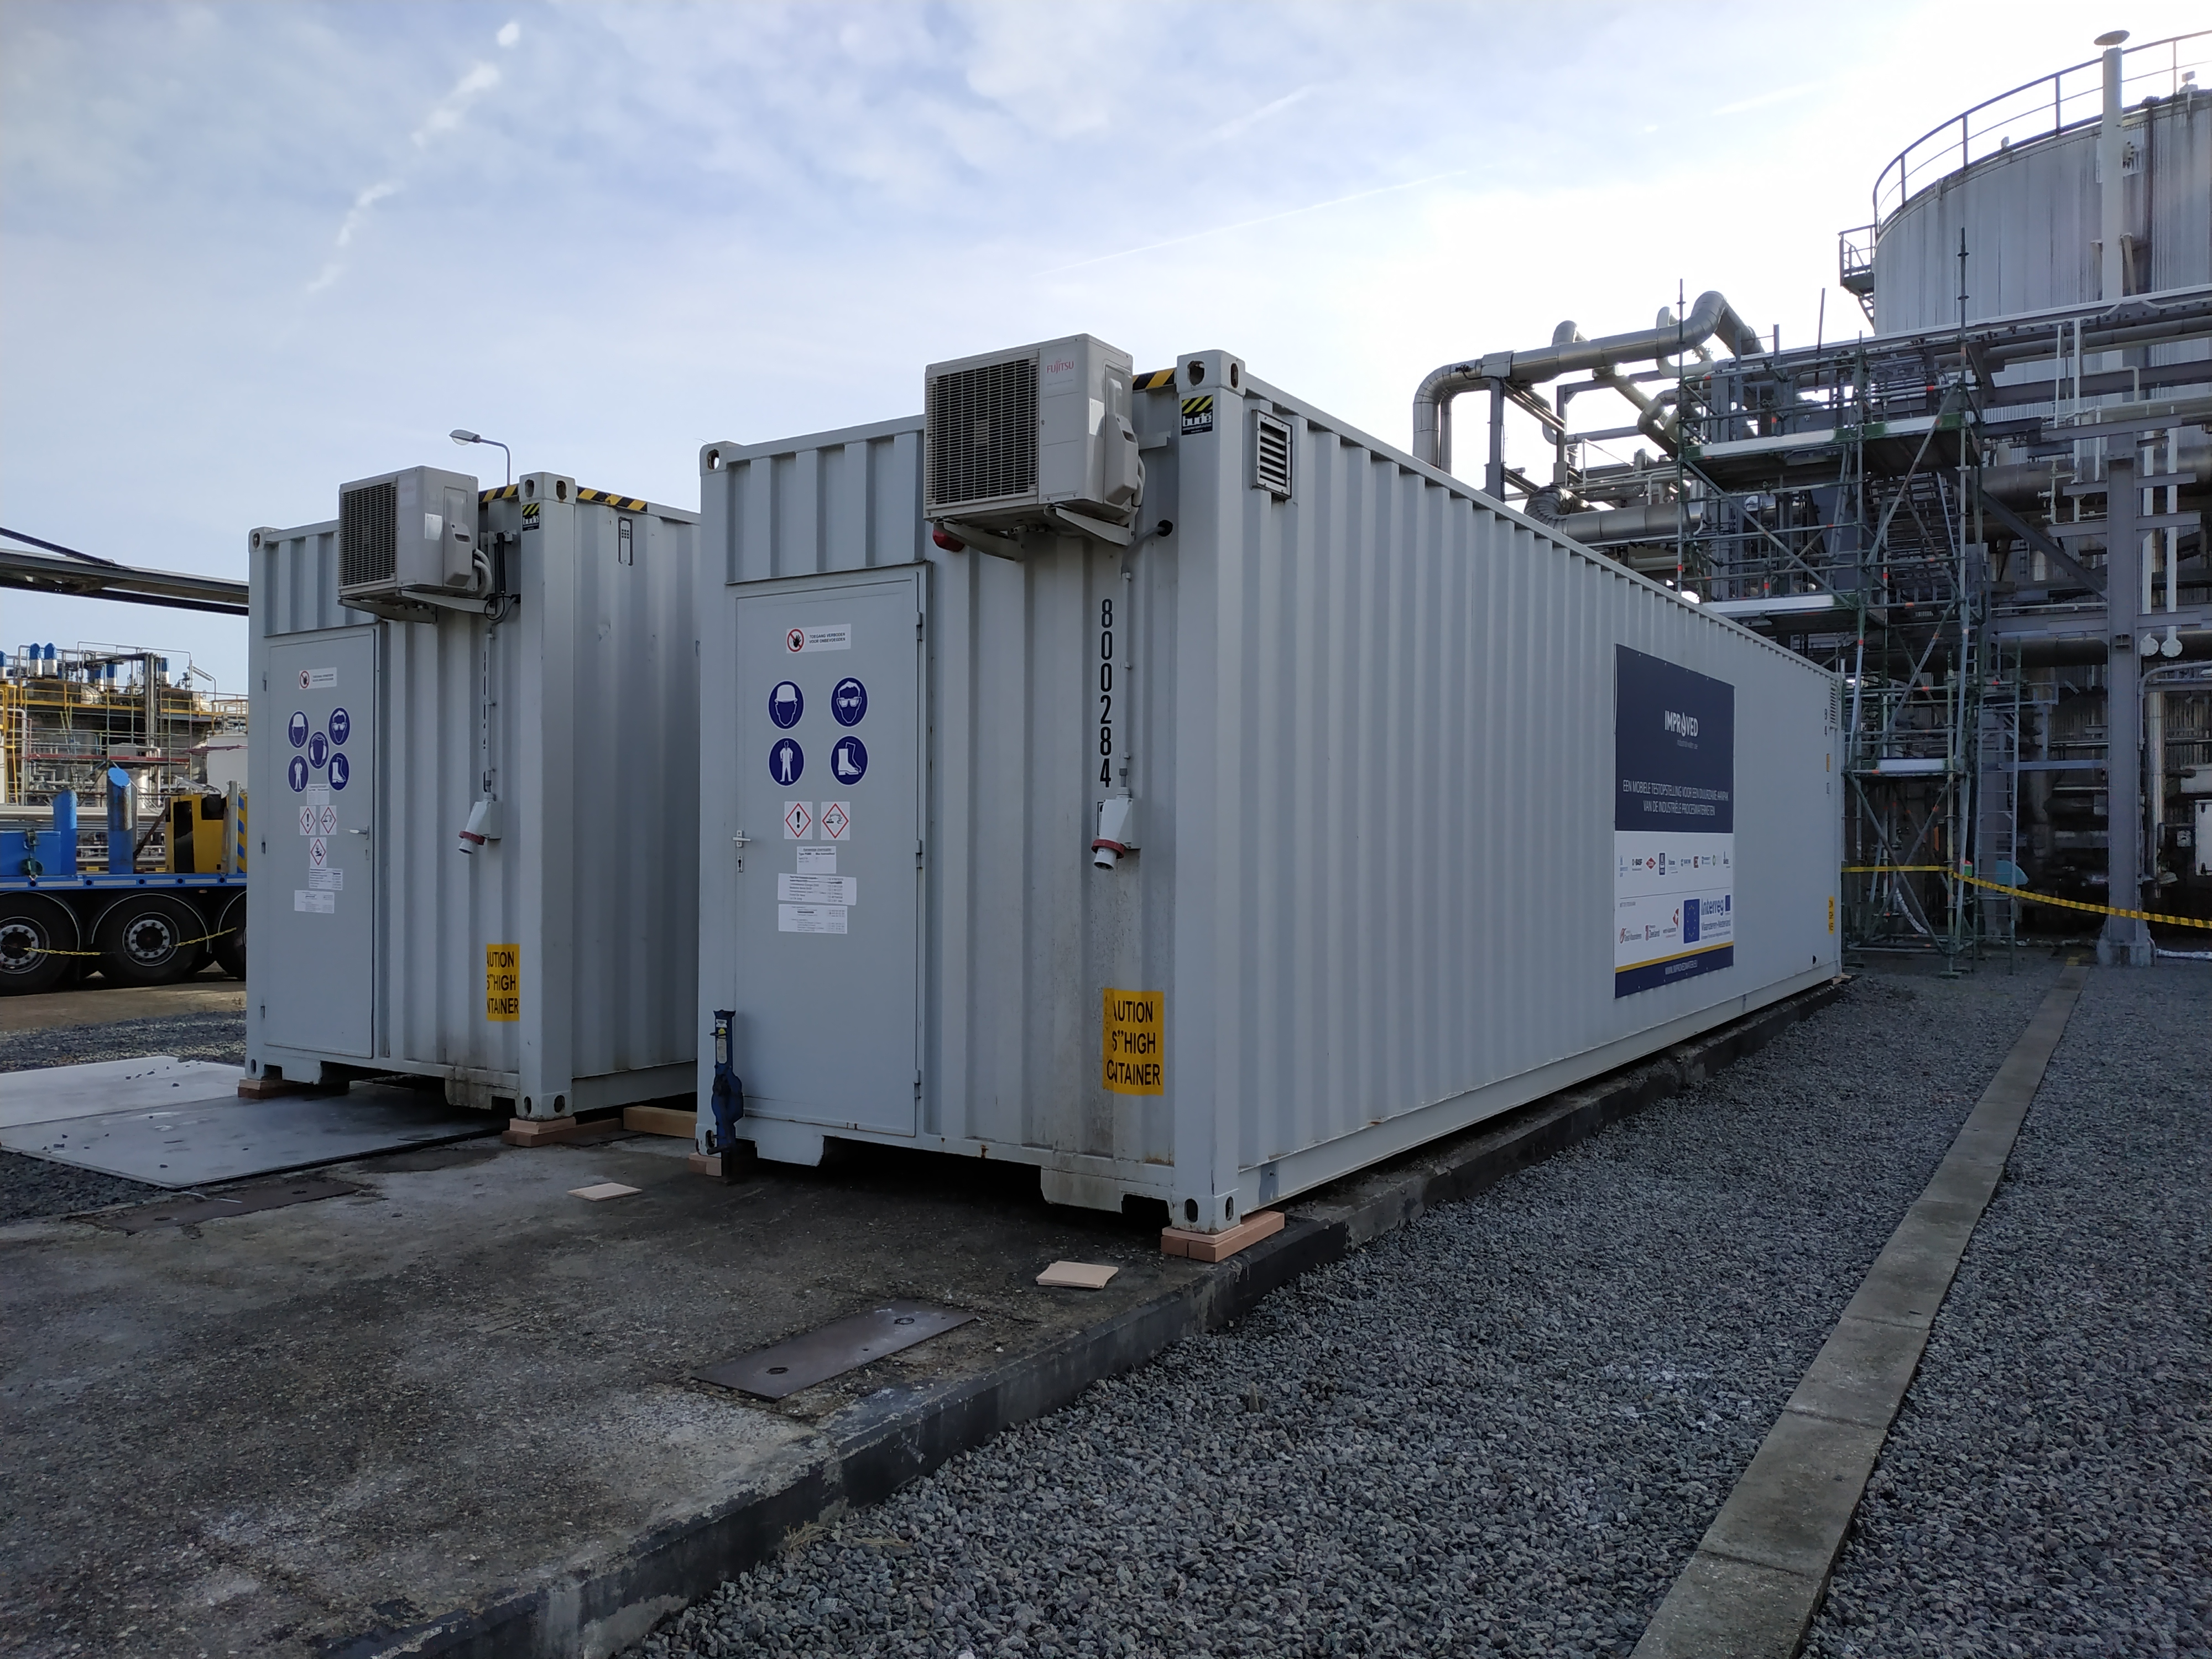
The Improved containers on site at Dow Terneuzen

Case study at Dow Terneuzen: test period February - July 2019
Main authors
Ivaylo Hitsov, PhD, UGent (Preparation of the report, main operator Improved)
Paul Hankinson, BSc., Evides Industriewater (Economic analysis calculations)
Correctors
Marjolein Vanoppen, PhD, UGent
Evelyn De Meyer, MSc., UGent
Nicolaas Van Belzen, BSc., Dow
David Moed, PhD, Evides Industriewater
Wilbert van den Broek, BSc., Evides Industriewater
Others involved
Nicolaas Van Belzen, BSc., Dow. Project supervision and support. Analytical data
Cornelis Groot, PhD, Dow – Project supervision
Sara Vernimmen, MSc. Dow. Project support
Melissa Dunkle, Dow – Alkalizing amine measurements
Evelyn De Meyer, MSc., UGent IC data analysis, Lab-scale technology screening, data interpretation
Han Cao, BSc., HZ – operator Improved containers. Preparation of RO normalization graphs
Bram Malfroot, MSc. UGent – Operator Improved containers. Lab-scale technology screening
Jorien Favere, MSc., UGent – Flow cytometry tests
Hans Cappon, PhD, HZ (RO data normalization Matlab code)
Dow control room operators P&U, shift supervisors and engineers
Ko De Jonge (Dow) and Eduard Erentreich (Engie) – Setup of the containers

Contents
1. Introduction 5
1.1 Problem Statement 5
1.2 Goal 6
2. Technologies of interest 7
2.1 Ion exchange 7
2.2 Reverse osmosis 7
2.3 Granular Activated Carbon (GAC) 8
3. Materials and Methods 9
3.1 Ion exchange 9
3.2 Reverse osmosis 9
3.3 Granular activated carbon 10
3.4 Flow cytometry 10
3.5 Economic evaluation 11
4. Results and Discussion 11
4.1 Description of the tested streams 11
4.2 Quality obtained using different technologies 14
4.2.1 Stream 1 14
4.2.2 Stream 2 18
4.2.3 D1 Tank water 21
4.3 Flow cytometry 24
4.4 Dissolved oxygen (DO) study on GAC and IEX systems 26
4.5 RO Normalization 28
4.6 Measurement train 32
4.7 Amine injection experiments 33
4.8 Pressure drop elevation on resin technologies 34
4.8.1 Pressure drop on Streams 1 and 2 34
4.8.2 Pressure drop on SAC-MB on D1 tank water 36
4.9 Economic evaluation 37
5. Conclusions 38
6. Acknowledgments 39
7. References 39

List of abbreviations 41
Appendices 42
A.1 LC-OCD test 22 Feb and 15 March - Stream 1 42
A.2 LC-OCD test 4 March and 5 Apr - Stream 2 43
A.3 LC-OCD test D1 tank water; High TOC period for Streams 1 and 2 44
A.4 Used equations 45
A.5 Principle of flow cytometry analyses 47

Introduction

Fresh water is of major importance for the chemical industry, as it is used in all kind of chemical processes. However, the continuous supply becomes more uncertain nowadays, as ground and surface water are depleting or getting less usable due to lower quality (i.e. too saline). The reuse and production of industrial process water as well as turning to alternative sources of water delivers a sustainable solution to this problem. In this research the potential of new technologies for boiler feedwater production from steam condensates and demiwater is investigated for the case of Dow Terneuzen, in the context of the IMPROVED project (Integrale Mobiele PROceswater Voorziening voor een Economische Delta).

Problem Statement

The production site of Dow Terneuzen is the second largest production site of Dow worldwide. The site production is focused around the ethylene crackers where naphtha together with LPG are converted into raw chemicals such as ethylene, propylene, butadiene and benzene. These monomers are used as raw material for other production plants on-site, belonging to Dow or other companies like Trinseo. Examples of these production plants are the Dow polyethylene plants, ethylene-oxide plant and polyols plant and the Trinseo Styrene and Polystyrene plants. Daily, up to 1700 employees and 600 contractors are involved in the plant operation.

To operate the plants, different steam grids (90 bar, 35 bar, 12.5 bar and 3.5 bar) exist on the Dow production site. Steam is used in steam turbines but also for other purposes like heating or steam cracking. Once the used steam is reduced/cooled down to steam condensate Dow aims to re-use these return condensates streams as much as possible. Heavily polluted condensate streams are discharged to the WWTP and are not in scope for this IMPROVED project. “Low polluted” or clean condensate return streams are preferably re-used for boiler feed water production.

“Clean” return condensate streams have not been in direct contact with product but can contain various water treatment chemicals. Also, small product leakages via leaking heat exchangers or dirty piping and equipment can result in lesser quality return condensates. These clean return condensate streams are treated in the Evides “Polished” water plant or at the ELSTA co-generation plant (see below). About 60% of the return condensates is re-used. Demin water is used to have sufficient water for boiler feedwater production.

Steam is produced at the ELSTA co-generation plant, P&U-boiler 5 or internally in the production plants by using excess heat. The ELSTA (ELectricity and Steam Association) plant consists of 3 natural gas fired turbines with a maximum duty of 123 MW and a steam turbine with a max. duty of 90 MW. Residual heat from the flue gas of the gas turbines combined with additional burners is used to produce 90 bar steam for the Dow site. Part of the 90 bar steam is sent to the steam turbine and/or reduced to 35 bar steam, also delivered to Dow. Part of the produced electricity is sent to Dow. The rest of the electricity is sent to the national electricity grid. The whole unit is operated based on demand for both steam and/or electricity.
ELSTA plant is property of Dow since September 2018.

The large demand of the plant for steam translates into large demand for high quality boiler feed. Although part of the return condensate can be used for boiler feedwater production, there will always be a need for additional demi water supply.

Demi water is produced from treated municipal wastewater (MBR Waterschap Drie Ambachten) and from Biesbosch water. Because the Zeeland region lacks large supply of fresh water, a significant fraction of the water supply for Dow is taken from the Biesbosch area and piped 120 km away from the Dordrecht region to the Braakman bassins. Braakman basins do supply the drinking water production facility and the regional industry water network.

Currently, the Dow Terneuzen site uses 22M m3 of fresh water per year. Currently ~80 percent of this water is sourced from re-use of internal streams, use of treated wastewater or local available surface water.
In Dow’s 2025 sustainability goals, specific targets are defined for the reduction of freshwater intake for the production sites. For the Dow Terneuzen site, Dow strives for minimizing the import of freshwater from the Biesbosch region. The focus of IMPROVED for the Dow case is on three return condensates. A blend of alkalizing amines is added to the boiler feed water for corrosion protection. After passing through heat exchangers and cooling down, the boiler feed water and the amines, together with their breakdown products end up in the condensates. Besides the amines, the return condensates have not been in direct contact with a product, and are therefore relatively clean in terms of ions with average conductivity around 5 µS/cm. The condensates, mixed with fresh demiwater, are currently polished by Evides Industriewater using mixed bed resins.

Goal

Mixed bed resin treatment was investigated as a benchmark technology. Special attention was payed to TOC, conductivity, cation conductivity and degassed cation conductivity of the water as main boiler feed water characteristics. Several tests with flow cytometry were performed on different treatment trains to determine the cell density and viability after treatment. The dissolved oxygen in the feed water and treatment trains was also studied as this is an important parameter for microbiological growth rate as well as corrosion rate.
A combination of strong acid cation (SAC) exchange resin followed by mixed bed was also tested. The SAC would remove the positively charged amines, followed by mixed bed for polishing. An advantage of such system is that the SAC can be backwashed in case of severe pressure drop due to fouling, while the mixed bed will guarantee good effluent quality. It should be noted that the mixed bed cannot be backwashed since the exhausted and fresh resins will be mixed, leading to reduced effluent quality.

Reverse osmosis (RO) was tested with main aim at TOC removal and secondary aim at deionization. TOC is a broad term, bracing many different components. Some of the components are charged and well rejected by ion exchange resins, other being neutral and rejected by RO, therefore a combination of RO and mixed bed polishing was also tested.

Granular activated carbon GAC was also tested for TOC removal. Activated carbon works by having large specific area where large, uncharged molecules can be absorbed on the surface of the carbon. Since this technology removes neutral components, it was also tested with different combinations of strong acid cation exchange resins and mixed bed resin polishing.

The GAC was also tested as a pretreatment for reverse osmosis, whereby the carbon was naturally inoculated and acted as a support media for bacteria. In this way the carbon biodegraded the easily biodegradable components in the water, reducing RO fouling. The excess biomass was periodically backwashed from the GAC.

Technologies of interest

Ion exchange

IEX is an electrochemically driven process. Ions are removed from the solution, because they are exchanged with ions already present on the IEX resin. In this specific case, regenerated cation resin (weak acid cation (WAC) and strong acid cation (SAC)) has H⁺, while regenerated anion resin has OH⁻ (strong base anion (SBA)) or a free base (weak base anion (WBA)) connected to its functional groups. The degasser (DG) removes CO₂ after cations are removed, therefore lowering the bicarbonate load to the anion resin. The mixed bed (MB) contains both SAC and SBA resin and polishes the water to < 1 µS/cm electrical conductivity (EC). The mixed beds can also be operated separately as a condensate polishing unit (CPU). As the IEX module removes ions, the resin slowly gets saturated, creating the need for a regeneration. By measuring pressure, EC, pH, TOC, sodium (Na) and silica (Si) before and after selected columns, the quality of the process can be monitored. A general overview of the IEX layout is provided in Figure 1. For more details about the operation of the IEX module, consult the document ‘Functional Description IEX-MB’.

For the case of Dow only SAC and MB and their combinations were interesting for the involved companies, therefore the rest of the vessels were either empty or hydraulically bypassed.

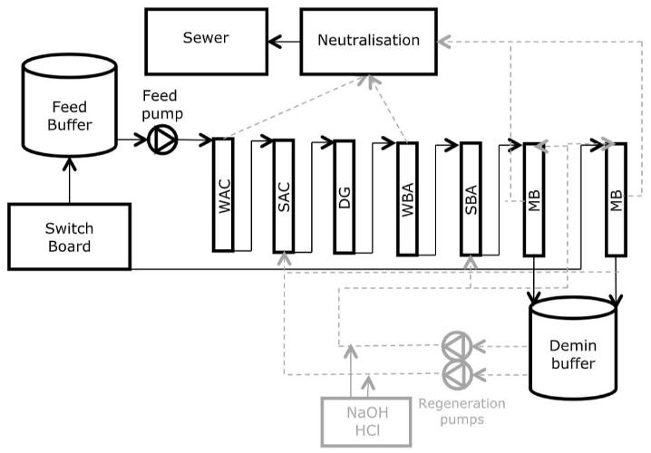
Figure 1. Schematic overview of the IEX module.

Reverse osmosis

In RO, a pressure gradient leads to separation through a semipermeable membrane. The RO membranes typically do not have visible pores and are considered dense membranes. The suspended solids are mechanically rejected by the membrane, while salts and water are dissolved into the active layer and the rejection is dictated by difference in diffusion coefficients of the water and solutes. Other factors such as membrane and solute charge also have a significant role in the determination of the rejection, but this is out of the scope of this report.

Salts, suspended solids, viruses, and dissolved components are retained in the concentrate, while water and some limited dissolved components move through the membrane in the permeate. RO membranes are typically not cleaned by backwashing but are mostly cleaned-in-place (CIP), or can be flushed with air (AIRO) to remove fouling and prevent clogging of the feed spacer. A general overview of the RO layout is provided in the Figure 2.

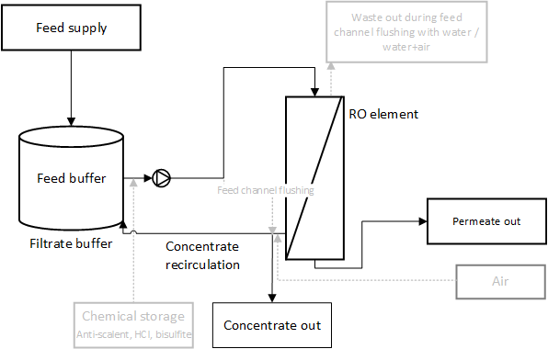
Figure 2. Schematic overview of the RO module.

Granular Activated Carbon (GAC)
In granular activated carbon treatment, large uncharged molecules attach to the surface of the carbon. The granules of the carbon have 3 classes of pores – macropores with diameter larger than 50 nm, mesopores with diameter 2-50 nm and micropores with diameter smaller than 2 nm. Typically, after use, the carbon is being replaced and sent to regeneration which can be done using either steam or thermal regeneration typically at 800 ºC and controlled atmosphere.

The activated carbon can also be used as biologically activated carbon, where biofilm is growing on the carbon and consumes biodegradable components. In this case, the carbon is not being replaced, but only backwashed to remove the excess biofilm when the pressure drop becomes excessive using filtrate water.

In the IMPROVED containers, there are 3 columns placed in series, which are operated GAC1, followed by GAC2 and GAC3.

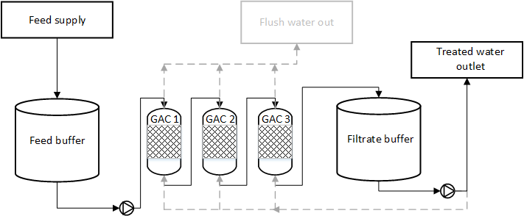
Figure 3 Process diagram of the granular activated carbon in the IMROVED containers

Materials and Methods

Ion exchange

The resins used in this setup are supplied by Dow - Table 1:
Table 1. Arrangement and resin type inside the IEX setup
Column | Bed height, fresh (cm) | Resin | Column height (cm)
WAC | 79 (6.2L) | Empty | 85
SAC | 136 (10.6 L) | Dowex 650C (H) | 145
Degasser
WBA | 116 (9.1 L) | Bypassed | 145
SBA | 136(10.6 L) | Bypassed | 145
MB1 | 140 (10.9 L) | Amberlite MB20 | 145
MB2 | 139 (10.9 L) | Amberlite MB20 | 145

The deionization happens from top to bottom in vertical columns with 10 cm internal diameter, while the regeneration happens in the opposite direction. The mixed bed columns are manually replaced with new resin instead of being regenerated. The hydraulic arrangement of the columns is WAC-SAC-Degasser-WBA-SBA-MB1. Since only MB and SAC-MB configurations were used at Dow, the rest of the columns were kept empty or hydraulically bypassed. Mixed bed 2 (MB2) is a separate unit that can be attached to another technology.

Reverse osmosis

In Figure 2, the scheme of the RO set-up is shown. The RO membrane was a Dow Filmtec LC HR-4040, with an active membrane area of 8.7 m². The pressure housing was a Codeline 40E100 (Lenntech, The Netherlands). The pH, flow, pressure, conductivity, free chlorine and temperature were continuously measured online with 2-minute sampling intervals. No antiscalant was dosed throughout the testing.

Granular activated carbon
The setup of the containers (Figure 3) consists of 3 columns in series with diameter of 28 cm, height of 1 m, filled until 0.68 m, resulting in 40 L volume each. The normal operational flow of the columns is from top to bottom with a flow rate of 300 L/h or 4.9 m/h filtration velocity. The backwash is performed from the bottom to the top at flow rate of 1300 L/h or 21.1 m/h backwash velocity.

After the carbon was exhausted (around 4 days), the experiments were continued until the carbon was biologically inoculated and since then, operated as a bioreactor - Figure 4 and Figure 5. Initially the TOC increases due to reduced absorption capacity of the carbon, followed by a decrease as the biology is developed. The biofilm is then converting the total carbon (TC) to CO2 or inorganic carbon (IC). In the tests at Dow, the carbon was never replaced, only backwashed.
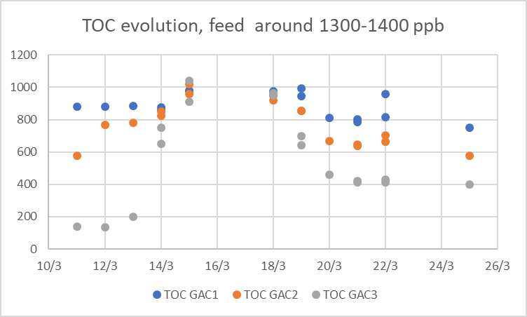  Figure 4 TOC evolution after the 3 GAC colums as the absobtion capacity is decreased and the biological activation develops | 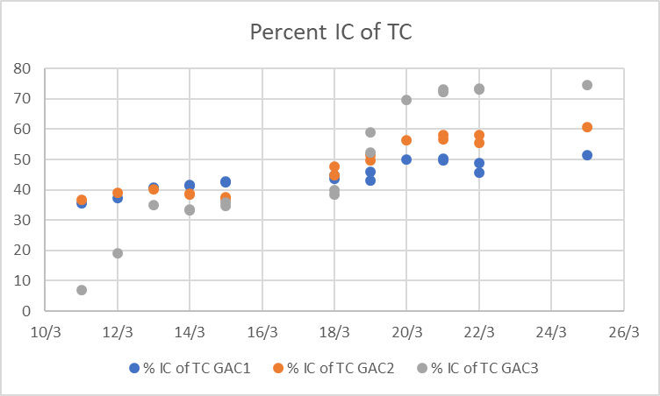  Figure 5 After the biological activation, the TOC is converted to IC, which is mainly CO2 due to biological respiration

Flow cytometry
Flow cytometry (FC) is an optical technique that allows fast quantification of microbial cells on a single-cell level, by aligning all particles in a single stream and then sending them past a laser beam. Their signal will be captured by multiple detectors. On the one hand, this technique detects the scatter of the particles, which is related to their size (forward scatter) and granularity (side scatter). On the other hand, the machine is equipped with multiple specific fluorescence detectors. To separate the microbial cells from the background noise caused by abiotic particles, the cells are targeted by, for example, fluorescent nucleic acid stains. This way, the concentration of cells can quickly be determined, within a total analysis time of 20 minutes. By combining multiple stains, the viability of the microbial community can also be determined. A general overview of the flow cytometric principle and the used flow cytometer is shown in appendix A.5 (Figure 57).

The total cell concentration was determined using the nucleic acid stain SYBR Green I (SG (Invitrogen, Belgium), 100x diluted in 0.22 μm-filtered dimethyl sulfoxide, 1 vol% final concentration). For viability analysis, SYBR® Green I was combined with propidium iodide (SGPI (Invitrogen, Belgium), 100x diluted in 0.22 μm-filtered dimethyl sulfoxide, 1 vol% final concentration). Propidium iodide will only enter permeabilized cells, whereas SYBR Green I will stain all cells. Based on the different emission spectrum of both stains, it is possible to discriminate the damaged from the intact cells. Samples were subsequently incubated in the dark for 20 min at 37 °C. The used flow cytometer was an Accuri C6+ (BD Biosciences, Belgium). Samples were run in fixed volume mode (25 µL) with a threshold of 500 on the green fluorescence channel signal height. Samples were measured in technical triplicates. Example output plots are included in Appendix A.5 (Figure 58).

Biofilm samples were sonicated and vortexed to loosen the biofilm prior to the flow cytometric analysis. Based on frequent measurements of the viable cell percentage with SGPI staining (shows damage caused by sonication) and the total cell concentration with SG staining (shows how much of the biofilm is loosened), an optimal sonication time of 30 minutes, followed by 30 seconds of vertexing, was determined. Samples were filtered over 20 µm filters (BD Biosciences, Belgium) to remove traces of bigger pieces of biofilm to avoid clogging of the machine.

Economic evaluation

An economic analysis was performed for the different water technologies for the condensate streams by Evides Industriewater. This was done to evaluate the economic viability of the treatment technologies for each stream and to discuss the trade-off between the obtained product water quality and the investment costs.

Results and Discussion
In this chapter, the results of all the demineralization technologies on the three different water streams is discussed.

Description of the tested streams
A simplified process diagram of the relevant streams can be seen in
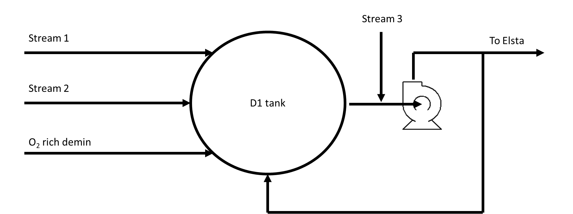
Figure 6 Simplified process diagram of the treated condensates and demin water flowing inside the D1 tank at Dow
Near the Improved containers, three condensates are mixed with demi-water and collected in a tank (D1). The first two condensates (Stream 1 and Stream 2) as well as the tank water sampled from the recirculation loop of the tank were tested inside the IMPROVED containers. All three condensates entering the D1 tank are return condensates which are clean (5-6 µS/cm) in terms of ionic composition since they have not been in direct contact with the product and most of the conductivity is due to the alkalizing amines. The current arrangement is causing problems in the condensate polishing unit, since the mixed beds are experiencing increased pressure drop, due to suspected biofouling. It is suspected that the mixing of the streams together with the oxygen rich water is causing biofouling, since the biological activity will be increased in the presence of oxygen.

All three contain blend of alkalizing amines, which was injected to the stream for corrosion protection. After the amines pass through the boiler, due to the high temperatures and pressures, partially breakdown to other components. The amines and their breakdown products, e.g. ammonia, volatile organic acids and others can be highly biodegradable in combination with phosphorus from the boiler blowdown as well as oxygen coming from the demi-water at the right temperature. The concentration of the three added alkalizing amines can be seen in Figure 7

Figure 7 Concentration of the added alkalizing amines and the tested streams

The concentration of the 3-methoxy propylamine and the Cyclohexylamine (CHA) is rather stable in the mixing tank of the containers between 0.5 and 1 mg/l. The concentration of the Monoethanolamine (MEA) however is changing in a wide range. While in the beginning of the experiments the MEA was beween 1 and 3.5 mg/l, towards the end of the experiments it was mostly not detected. While it is possible that the biology inside the mixing tanks is removing the MEA, the 3-methoxypropylamine should also be affected as it is of similar molecule size and the GAC was able to remove it biologically as seen later in the report. The amine concentration does not seem to be different in the different streams.

The treated condensate streams were in fact so highly biodegradable that biology started to develop inside the filters of the TOC analyzers only after several days of operation and the online value would be 0.5 mg/l lower than the value of a grab sample. Thereafter, the TOC was taken only with grab samples.

An overview of the streams treated inside in Improved can be seen in Table 2.
Table 2 Main parameters of the tested streams
Stream | Temp | Cond | pH | Na | SiO₂ | TOC | IC | TC
 | ºC | µS/cm |  | µg/l | µg/l | µg/l | µg/l | µg/l
# Samples | 74 | 74 | 74 | 57 | 57 | 74 | 57 | 57
Stream 1 σ | 3.1 | 0.7 | 0.6 | 0.8 | 0.9 | 168.9 | 108.9 | 160.5
Stream 1 | 20.2 | 5.4 | 8.7 | 1.0 | 1.6 | 1447.0 | 306.4 | 1766.1
# Samples | 30 | 30 | 30 | 28 | 28 | 30 | 18 | 18
Stream 2 σ | 3.0 | 1.9 | 1.3 | 160.3 | 5.4 | 273.5 | 172.0 | 404.6
Stream 2 | 22.8 | 6.6 | 7.8 | 203.4 | 14.8 | 1462.7 | 652.4 | 2120.6
# Samples | 45 | 45 | 45 | 45 | 44 | 45 | 45 | 45
D1 tank σ | 2.6 | 1.0 | 0.9 | 23.7 | 2.7 | 207.2 | 146.8 | 300.6
D1 tank | 18.0 | 6.3 | 6.9 | 47.2 | 6.2 | 1625.8 | 666.5 | 2268.9

The three different condensates come from different units at Dow and have different conditioning. Stream 2 also contains phosphate, sometimes several mg/l, which can aid biological activity. This stream also contains around 200 µg/l sodium measured with the online sodium meter inside the containers. The sodium is added by Dow as sodium polyphosphate as well as NaOH for pH control.

The D1 tank water stream also contains some sodium, usually around 50 µg/l, possibly coming from Stream 2. As expected, the sodium of D1 matches the Sodium measured at ELSTA (also receiving the tank water).

Figure 8 Sodium measured in ELSTA as well as sodium measured in the streams received in the containers of Improved, µg/l

It should be noted that in general the sodium is too high in Stream 2 and inside the water received in ELSTA.
The pH measured in the containers is not correct. While in the beginning of the experiments, the measurements showed pH 9 and above for the feed water, later the pH measurement drifted down to as low as pH 6. This was later attributed to iron fouling. Cleaning in place with HCl at pH 1 revived the sensors and the measurements returned to realistic range, but they fouled very quickly later, especially while running on D1 tank water. Therefore, pH data was provided by Dow – Figure 9.

Figure 9 pH of the three streams during the testing period, data provided by Dow Terneuzen
The general guideline for pH of returning condensates in iron-copper systems is between 8.8 and 9.2 [1]. The pH of Stream 1 is in the normal range. The pH of Stream 2 is higher than this range most of the time, but within normal limits. The pH of D1 tank water is rather low and in the beginning of July becomes lower than 8, possibly due to acidification of the stream due to biological activity.

The temperature of the streams received inside the containers is similar, since they were cooled down by a thermostatically controlled chiller with a set point of 20 ºC.

The conductivity of the three streams is also similar. It should be noted that the measurement was done with a step of 1.2 µS/cm. The higher conductivity of Stream 2 can also be due to the elevated sodium levels. The Sodium is added to this stream as sodium polyphosphate and NaOH for pH control.

The ionic composition of the streams can be seen in Table 3

Table 3 Ionic composition of the three tested streams
Stream | Formate | Acetate | Cl- | NO2 | Propionate | PO4 | SO4 | Na | NH4 | K | Ca | Mg
 | µg/l | µg/l | µg/l | µg/l | µg/l | µg/l | µg/l | µg/l | µg/l | µg/l | µg/l | µg/l
Samples | 12 | 12 | 12 | 12 | 12 | 12 | 12 | 12 | 12 | 12 | 12 | 12
St. Dev. | 4.1 | 65.7 | 5.3 | 3.9 | 12.3 | 0.0 | 1.9 | 47.3 | 165.6 | 5.0 | 51.2 | 39.3
Stream 1 | 1.8 | 59.5 | 1.6 | 1.2 | 8.7 | 0.0 | 0.6 | 15.2 | 295.8 | 1.5 | 56.0 | 39.3
Samples | 6 | 6 | 6 | 6 | 6 | 6 | 6 | 6 | 6 | 6 | 6 | 6
St. Dev. | 0.0 | 64.2 | 3.7 | 6.7 | 0.0 | 171.5 | 6.1 | 81.4 | 72.3 | 0.0 | 39.1 | 34.3
Stream 2 | 0.0 | 63.2 | 1.7 | 3.0 | 0.0 | 165.8 | 11.2 | 151.2 | 288.2 | 0.0 | 54.3 | 26.0
Samples | 7 | 7 | 7 | 7 | 7 | 7 | 7 | 8 | 8 | 8 | 8 | 8
St. Dev. | 0 | 0 | 10.5 | 7.5 | 0 | 0 | 18.6 | 38.9 | 96.6 | 0.0 | 28.4 | 24.1
D1 tank | 0 | 0 | 4.3 | 4.7 | 0 | 0 | 11.7 | 61.3 | 371.6 | 0.0 | 10.8 | 9.1

It is interesting to note that the easily biodegradable acetate and phosphate, detected in Streams 1 and 2 are not detected in the tank water suggesting their biological degradation inside the D1 tank.

Quality obtained using different technologies

Stream 1
Since a lot of the components are below detection limits in treated condensate streams, the conductivity and the TOC are the most commonly used parameters to evaluate the quality of the water. The conductivity was measured using an online conductivity meter from Swan, Switzerland.

The specific conductivity is simply the normal conductivity of the stream. After that the water passes through cation exchange resins where the cations are replaced with H⁺ ions. Because of this, the pH of the stream is reduced, and normally this step acts as a conductivity multiplier, except for specific cases where the ionic composition is dominated by bases (e.g. NaOH, NH₃), where the pH is returning to more neutral values. In these cases, the cation conductivity can be even lower than the specific. Finally, the water passes through a degasser, where the temperature is kept just below the boiling point and the volatile components are purged (e.g. volatile acids, (bi)carbonates, remaining ammonia after the cation resins, etc.). The degassed cation conductivity is the most important parameter of the water since before the boiler the water is pre-heated. Dow strives to achieve a treatment train with cation conductivity below 0.1 µS/cm and does not have a limit for degassed cation conductivity or TOC. While there is no set limit for TOC, it should still be minimized.

More attention was payed to the MB configuration since this is the benchmark technology currently applied at Dow. Also, the results of SAC-MB are of high importance since this is the most probable new condensate polishing installation that Evides Industriewater is going to build. GAC and GAC-MB were performing promising in the lab-scale pre-screening in terms of TOC [2].

The quality obtained with the different technologies on Stream 1 can be seen in Table 4:
Table 4 Quality obtained with different technological train on Stream 1
Train | From | To | SC | CC | DCC | Na | SiO₂ | TOC
 |  |  | µS/cm | µS/cm | µS/cm | µg/l | µg/l | µg/l
# Samples | Combined from: |  | 48 | 48 | 48 | 34 | 34 | 48
St. Dev. | 11-Mar | 28-Mar | 0.04 | 0.04 | 0.01 | 0.14 | 2.63 | 31.5
Average MB | 05-Jun | 26-Jun | 0.083 | 0.136 | 0.101 | 0.15 | 1.31 | 183.2
# Samples |  |  | 15 | 15 | 15 |  |  | 16
St. Dev. |  |  | 0.000 | 0.008 | 0.009 |  |  | 6.5
Average SAC-MB | 14-Feb | 27-Feb | 0.056 | 0.127 | 0.129 |  |  | 173.9
# Samples |  |  | 17 |  |  |  |  | 16.0
St. Dev. |  |  | 0.29 |  |  |  |  | 91.2
Average RO | 13-Feb | 27-Feb | 0.99 |  |  |  |  | 364.2
# Samples |  |  | 5 | 5 | 5 |  |  | 5
St. Dev. |  |  | 0.008 | 0.013 | 0.004 |  |  | 2.2
Average MB-RO | 17-Jun | 20-Jun | 0.670 | 0.703 | 0.086 |  |  | 31.0
# Samples |  |  | 22 |  |  | 21 | 21 | 22
St. Dev. |  |  | 0.0 |  |  | 0.1 | 2.4 | 18.2
Average GAC-MB | 11-Mar | 28-Mar | 0.1 |  |  | 0.2 | 1.1 | 94.7
# Samples |  |  | 3 | 3 | 3 | 3 | 3 | 3
St. Dev. |  |  | 0.001 | 0.003 | 0.001 | 0.0 | 2.2 | 7.6
Average GAC-SAC-Deg-MB | 28-Mar | 29-Mar | 0.067 | 0.118 | 0.094 | 0.1 | 6.5 | 92.6
HIGH TOC
# Samples |  |  | 8 | 8 | 8 | 10 | 10 | 10
St. Dev. |  |  | 0.002 | 0.016 | 0.021 | 0.1 | 0.3 | 185.7
Average SAC-MB | 10-May | 17-May | 0.069 | 0.152 | 0.134 | 0.2 | 1.3 | 470.8
# Samples |  |  | 10 | 10 | 10 | 10 | 10 | 10
St. Dev. |  |  | 0.071 | 0.076 | 0.078 | 0.2 | 0.3 | 84.8
Average SAC-MB-RO | 10-May | 17-May | 0.705 | 0.728 | 0.149 | 0.3 | 0.9 | 189.8

The SiO₂ and Na measurements in Table 4 are based on the average from either the online measurement or a grab sample using the online instruments of Swan, Switzerland. Na and SiO₂ are important parameters and can be used to evaluate the performance of MB, for example exhausted cationic resins when Na breaks through or exhausted anion resins when SiO₂ breaks trough. It is interesting to note that whenever SiO₂ breaks through due to exhausted SBA part of a mixed bed, it usually is in much higher levels than the SiO₂ level in the feed. Since the affinity of SiO₂ for SBA resins is small, when the SBA gets exhausted the SiO₂ start to desorb and make space for components that are easier to attach to the SBA.

Wherever cation and degassed cation measurements are missing in Table 4, the specific conductivity from the skids was taken.

In order to better visualize the experimental data, the conductivities as well as the TOC and the standard deviation of the measurements are plotted in Figure 10, Figure 11, Figure 12 and Figure 13:
Figure 10 Specific conductivity (SC), Stream 1 µS/cm | Figure 11 Cation conductivity (CC), Stream 1 µS/cm
Figure 12 Degassed cation conductivity (DCC), Stream 1 µS/cm | Figure 13 TOC Stream 1, µg/l

The MB and the SAC-MB configuration are working very close in terms of TOC-removal, this means that the amines and their positively charged breakdown products are easily removed and adding more cation exchange resins does not improve the removal of TOC. The normal and cation conductivity are similar, but the degassed cation conductivity of the SAC-MB train is higher than the MB train. Since the SAC-MB train has a large excess of SAC resins, it is possible that there is an excess of H+ ions lowering the pH and increasing the conductivity. This pH of the produced water was never measured, so this theory remains unconfirmed. The LC-OCD analysis in Appendix A.1 Figure 52 shows no appreciable reduction of glycol, glycose isopropylalcohol (IPA), since they are not charged. Monoethanol amine (MEA), cyclohexanone and cyclohexylamine (CHA) are well rejected already by the SAC column. The cyclohexanone is not ionizable in normal pH range and should not be removed by SAC resins. Therefore, it is possible that its detection is incorrect and could be 3-methoxypropylamine instead. The ammonia is also completely rejected by the SAC column. This suggests that it is either completely broken down in the process or its peak is detected as another component due to being too close in retention time. Interestingly the cTEP (transparent colloidal particles that are associated with membrane fouling potential) increase with each treatment step – 8 µg/l in the mixing tank, 16 after SAC and 32 after MB. This suggest biological activity on the resin train.

The RO configuration has quite high TOC, which is explained by the volatility of the amines. Volatile components are harder to remove with RO. The MB-RO configuration was tested as part of experiments to evaluate the influence of TOC on the conductivity. The performance of this configuration was very good, with TOC of only 31 µg/l and degassed cation conductivity of 0.086 µS/cm. This shows that RO and resin technologies is a good combination and produce excellent quality water. It should be noted that the cation conductivity if this configuration is quite high at 0.703 µS/cm possibly due to RO absorbing carbonates from the air from the headspace of the buffer tank and the recirculation of the RO to this tank. This problem should not exist on full-scale. The carbonates can also be an indication of biological activity (producing CO₂), but this should not be the case considering the <200 µg/l TOC effluent of MB. The LC-OCD test of RO in Appendix A.1 Figure 52 shows 2/3 reduction of glycose and glycol and 50% reduction of IPA. MEA, cyclohexanone (probably 3-methoxypropylamine) and CHA were rejected in increasing order due to the larger size molecule and thus decreasing volatility of the latter. The ammonia was 80% rejected.

GAC-MB configuration also performed very well in terms of TOC producing effluent of 94.7 µg/l. It should be noted that the GAC is working as a bioreactor and the removed TOC is being converted to CO₂ which dissolves into the water and is being later removed by the SBA part of the MB. Unfortunately, the cation and degassed cation conductivity of this configuration was not measured. Later the system was modified, allowing a daily grab sample measurement of the conductivity. The LC-OCD analysis in Appendix A.1 Figure 53 of this configuration shows that GAC removed almost completely the glycol and the glycose and reduced the IPA by 69 percent. The MEA was also completely rejected, but the cyclohexanone (probably 3-methoxypropylamine) was only 14% rejected and the CHA was increased. This increase is probably due to overlapping peaks of cyclohexanone and CHA. Therefore, it can be concluded that GAC removed easiest the components with small molecule that elude first.

The GAC-MB system was performing well, but the components removed by the biology of the GAC were loading the SBA of the MB. Therefore, a new configuration was tested – GAC-SAC-Deg-MB. The idea of this configuration is that the GAC is removing most of the TOC, the water is then passed through a SAC column and since there are enough cations to decrease the pH, the carbonates produced by the GAC can be removed by the degasser as CO₂. The MB then polishes the water with minimal ionic load. This configuration was working very well in terms of quality on Stream 1 – average TOC was 92.6 µg/l and the average degassed cation conductivity was 0.094 µS/cm. This technological train is probably not applicable due to the high capital investment cost. Moreover, further testing on other streams showed rapid pressure drop increase on the SAC column possibly due to the biomass coming from the GAC.

During the “High TOC” period SAC-MB-RO train was operated. The high TOC period for Stream 1 was not much higher than the normal TOC period (1766±160 vs 1897±307 µg/l), however, the composition of the incoming stream was different. The quality of the SAC-MB configuration was about twice worse in terms of TOC and the DCC was about 50% higher for the high TOC period. An LC-OCD sample was taken during this period, but unfortunately the mix tank vial was broken in the shipping and only the effluent of the trains could be analyzed – Appendix A.3 Figure 56. The effluent of MB had large amount of glucose as well as unidentified low molecular weight component as well as IPA. The unidentified low molecular weight component is completely rejected by RO, suggesting that it is not volatile. The glucose was 80% rejected by the RO and the IPA was 40% rejected. Overall it is strange that the RO permeate had higher degassed cation conductivity than the influent coming from the MB. The RO adds a lot of inorganic carbon that comes from the air and in high concentrations the degasser has troubles to purge it. An example of this can be seen by comparing the cation and the degassed cation conductivity of a mixed bed with SBA part that is gradually becoming exhausted Figure 14 and Figure 15.

Figure 14 Cation conductivity of a mixed bed with SBA part being gradually exhausted, µS/cm | Figure 15 Degassed cation conductivity of a mixed bed with SBA part being gradually exhausted, µS/cm

As seen as the inorganic carbon (IC) load increases due to the exhausted SBA part of the MB resins, the degasser has troubles removing all of the IC and spikes start to appear in the degassed cation conductivity measurement. While the mixed bed was not exhausted in the SAC-MB-RO experiment, the RO itself adds IC from the atmosphere due to the open buffer tank and the DCC measurement was not stable. In fact, if only two measurements are removed from the DCC of the RO, the average value becomes 0.110 µS/cm, which is lower than the 0.134 µS/cm obtained from SAC-MB.

Stream 2

The quality obtained with the different technologies on Stream 2 can be seen in Table 5.

Table 5 Quality obtained with different technologies on Stream 2
Train | From | To | SC | CC | DCC | Na | SiO₂ | TOC
 |  |  | µS/cm | µS/cm | µS/cm | µg/l | µg/l | µg/l
# Samples |  |  | 1 | 1 | 1 | 13 | 13 | 13
St. Dev. |  |  | 0.00 | 0.00 | 0.00 | 0.12 | 1.24 | 77.88
Average MB | 01-Apr | 12-Apr | 0.118 | 0.178 | 0.098 | 0.2 | 2.8 | 274.9
# Samples | Combined from |  | 18 | 18 | 18 | 15 | 16 | 18
St. Dev. | 01-Mar | 08-Mar | 0.010 | 0.016 | 0.018 | 0.5 | 1.7 | 39.1
Average SAC-MB | 21-May | 03-Jun | 0.063 | 0.129 | 0.121 | 0.4 | 1.4 | 279.1
# Samples |  |  | 9 |  |  | 7 | 7 | 9
St. Dev. |  |  | 0.12 |  |  | 2.6 | 0.2 | 58.9
Average RO | 01-Mar | 08-Mar | 0.71 |  |  | 25.1 | 0.1 | 304.7
# Samples |  |  | 5 | 5 | 5 | 5 | 5 | 5
St. Dev. |  |  | 0.149 | 0.187 | 0.015 | 2.1 | 1.4 | 13.9
Average SAC-MB-RO | 21-May | 03-Jun | 0.705 | 0.764 | 0.097 | 1.7 | 2.8 | 114.8
# Samples |  |  | 12 | 12 | 12 | 11 | 11 | 11
St. Dev. |  |  | 0.031 | 0.031 | 0.010 | 0.1 | 1.6 | 27.8
Average GAC-SAC-Deg-MB | 01-Apr | 12-Apr | 0.115 | 0.164 | 0.115 | 0.3 | 4.4 | 170.6
HIGH TOC
# Samples |  |  | 7 | 7 | 7 | 7 | 7 | 7
St. Dev. |  |  | 0.003 | 0.032 | 0.035 | 0.1 | 1.4 | 2018.9
Average SAC-MB | 22-May | 27-May | 0.071 | 0.173 | 0.149 | 0.3 | 4.3 | 3587.4
# Samples |  |  | 7 | 7 | 7 | 6 | 6 | 7
St. Dev. |  |  | 0.035 | 0.030 | 0.012 | 0.1 | 0.6 | 74.4
Average SAC-MB-RO | 22-May | 27-May | 0.712 | 0.761 | 0.104 | 0.2 | 1.9 | 191.4

In order to better visualize the experimental data, the conductivities as well as the TOC and the standard deviation of the measurements are plotted in Figure 16, Figure 17Figure 11, Figure 12Figure 18 and Figure 19:

Figure 16 Specific conductivity (SC), Stream 2 µS/cm | Figure 17 Cation conductivity (CC), Stream 2 µS/cm
Figure 18 Degassed cation conductivity (DCC), Stream 2 µS/cm | Figure 19 TOC Stream 2, µg/l

As with the results from Stream 1, the SAC-MB and the MB configuration do not differ in terms of TOC. Similarly, the degassed cation conductivity of SAC-MB is yet again higher than the DCC of MB effluent, however it should be noted that the measurement of the degassed cation conductivity of MB was measured only once. The LC-OCD analysis of the SAC-MB configuration can be seen in Appendix A.2 Figure 54 and for the MB configuration it can be seen in Appendix A.2 Figure 55.

The detected DAEA in Appendix A.2 Figure 54 is probably cyclohexylamine due to similar elusion times and the cyclohexanone in Figure 55 is probably 3-methoxypropylamine as discussed previously.

The LC-OCD analysis of the two samples from the mixing tanks differ significantly – there is no ammonia in the March 4th sample and the sample of April 5th does not have any MEA. Also, the detected of dissolved organic carbon was twice higher in the March 4th sample. Since ammonia is a breakdown product of the amines, possibly the process conditions in the boiler differed, while for the MEA, it is possible that the signal was masked by the neighboring cyclohexanone peak. The SAC-MB configuration expectedly did not remove any appreciable amounts of glucose, glycol and IPA. However, the removal of the amines was complete as well as the low molecular weight acids. The results from the standalone mixed bed are similar.

The RO effluent on the average had 305 µg/l TOC. Unfortunately, the cation and degassed cation conductivity were never measured. The LC-CD in Appendix A.2 Figure 54 shows that RO reduced glycol and glucose by 50%, while the IPA was reduced only by 15%. The rejection of MEA, 3-Methoxypropylamine and CHA was 73, 90 and 98%, respectively. The RO also rejected completely the low molecular weight acids.

The SAC-MB-RO configuration had excellent degassed cation conductivity of 0.097 µS/cm and TOC of 115 µg/l.

The GAC-SAC-Deg-MB configuration also performed very well in terms of degassed cation conductivity and TOC with 0.115 µS/cm and 170.6 µg/l, respectively. While the degassed cation conductivity is marginally lower than the one of SAC-MB at 0.121 µS/cm, the TOC is much lower than the one of SAC-MB (279 µg/l). The LC-OCD results can be seen in Appendix A.2 Figure 55. The GAC completely removes the glucose and recuses the IPA from 16 to 9 µg/l. From the amines only 8 µg/l of MEA are left after GAC. The SAC and the MB do not significantly affect the concentration of IPA, but remove completely the remaining MEA. The ammonium is not removed by the GAC, if fact it is slightly increased. While this can be a measurement error, it is also possible that the ammonium is coming from the GAC as new carbon is known to release ammonium and silica.

During the “High TOC” period a leaking heat exchanger was releasing product into the condensate. The exact nature of this product is unknown. The LC-OCD suggests a small molecule product that eludes quickly. Unfortunately, no LC-OCD samples were taken from SAC-MB and SAC-MB-RO during this period. In the peak of the high TOC on 23 May, the TOC of the mixing tanks was 10.3 mg/l, the effluent of SAC-MB was 6.06 mg/l with 0.185 µS/cm DCC. The SAC-MB-RO had a DCC of 0.121 µS/cm and TOC of 252 µg/l. We can conclude that most of the incoming TOC was low molecular neutrals with non-volatile molecule that is well rejected by RO.

D1 Tank water
The quality obtained with the different technologies on D1 tank water can be seen in Table 6.
Table 6 Quality obtained with different technologies on D1 tank water
Train | From | To | SC | CC | DCC | Na | SiO₂ | TOC
 |  |  | µS/cm | µS/cm | µS/cm | µg/l | µg/l | µg/l
# Samples |  |  | 5 |  |  | 5 | 5 | 5
St. Dev. |  |  | 0.00 |  |  | 0.42 | 0.9 | 120.5
Average MB | 12-Apr | 16-Apr | 0.10 |  |  | 0.6 | 2.7 | 500.2
# Samples | Combined from: |  | 19 | 19 | 19 | 30 | 30 | 37
St. Dev. | 27-Jun | 11-Jul | 0.012 | 0.028 | 0.022 | 0.1 | 1.6 | 66.9
Average SAC-MB | 24-Apr | 09-May | 0.073 | 0.118 | 0.102 | 0.3 | 2.6 | 302.6
# Samples |  |  | 5 |  |  | 4 | 4 | 5
St. Dev. |  |  | 0.24 |  |  | 1.8 | 1.4 | 23.2
Average RO | 03-May | 07-May | 1.50 |  |  | 12.1 | 2.9 | 82.0
# Samples |  |  | 4 | 4 | 4 | 4 | 4 | 4
St. Dev. |  |  | 0.037 | 0.041 | 0.005 | 1.3 | 1.9 | 3.2
Average SAC-MB-RO | 07-May | 09-May | 0.484 | 0.522 | 0.088 | 1.3 | 4.1 | 51.3
# Samples | Combined from: |  | 19 | 19 | 19 | 15 | 15 | 34
St. Dev. | 24-Apr | 02-May | 0.150 | 0.121 | 0.063 | 4.1 | 1.0 | 10.6
Average GAC-RO | 27-Jun | 11-Jul | 2.672 | 2.588 | 0.200 | 5.2 | 0.86 | 11.5
# Samples |  |  | 13 | 13 | 13 | 13 | 13 | 14
St. Dev. |  |  | 0.014 | 0.022 | 0.017 | 0.0 | 0.7 | 6.6
Average GAC-RO-MB | 24-Apr | 02-May | 0.111 | 0.166 | 0.086 | 0.1 | 0.8 | 15.3
# Samples |  |  | 2 | 2 | 2 | 2 | 2 | 2
St. Dev. |  |  | 0.007 | 0.005 | 0.004 | 0.0 | 1.4 | 41.0
Average GAC-SAC-Deg-MB | 12-Apr | 15-Apr | 0.089 | 0.116 | 0.095 | 0.3 | 4.8 | 301.0

In order to better visualize the experimental data, the conductivities as well as the TOC and the standard deviation of the measurements are plotted in Figure 20, Figure 21, Figure 22 and Figure 23:

Figure 20 Specific conductivity (SC), D1 µS/cm | 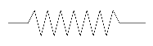  Figure 21 Cation conductivity (CC), D1 µS/cm
Figure 22 Degassed cation conductivity (DCC), D1 µS/cm | Figure 23 TOC D1, µg/l

This stream is a special case, the water entering the containers is coming from the D1 tank which is a mixture of the 3 condensate streams and demin water. There is also a suspicion that there is a biological activity inside the tank itself. Moreover, this stream contained a lot dissolved oxygen before entering the containers (2-3 mg/l, see chapter 4, section 4.44.4) as well as rust particles and on one occasion a draining point of the feed line was completely blocked by settled rust. To prove that rust particles exist in the stream a magnet was placed inside the empty cartridge filter housing of the GAC and a sample of magnetic particles was collected over 10 days at 200 l/h - Figure 24. These factors made the stream very challenging for treatment inside the containers. The RO experienced feed spacer fouling when used without pretreatment. The resin technologies also experienced increased pressure drop very quickly compared to the other streams.

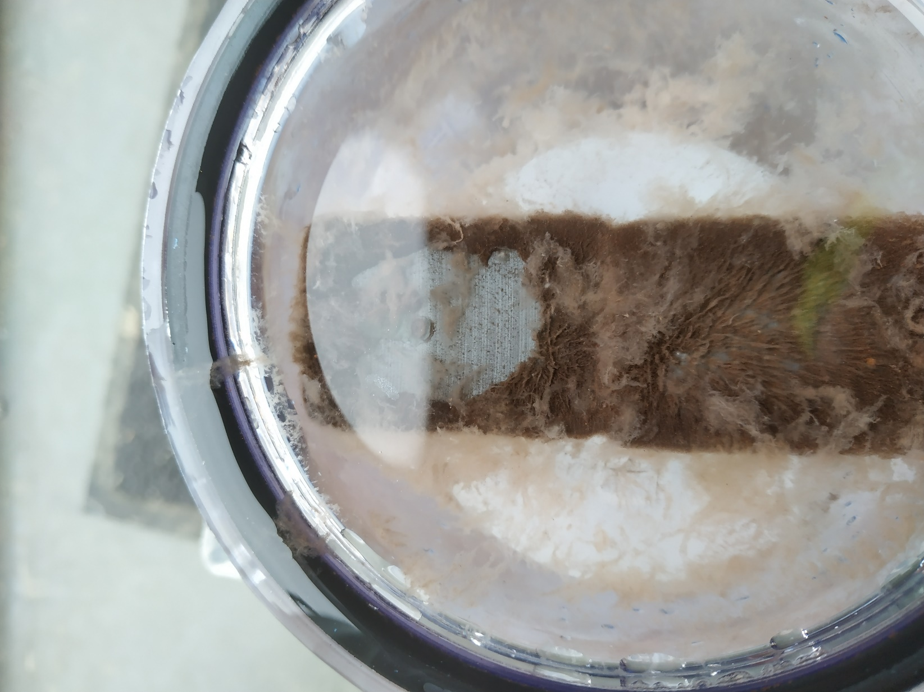
Figure 24 Particles collected on a ferrite magnet inside an empty cartridge filter housing. Experiment performed for 10 days at 200 l/h. Biofouling formed inside the housing can also be observed. D1 tank water.

The MB configuration performed very poorly in terms of TOC (sometimes over 600 µg/l and on average 500.2 µg/l) and therefore and after a quick test the configuration was changed to SAC-MB. It should be noted that this was the first technology tested on the stream and although it was flushed thoroughly, the sampling point might have still been contaminated with stagnant water and therefore the TOC composition might be altered.

SAC-MB performed better in terms of TOC and resulted in 302.6 µg/l. It should be noted that this was the only stream where SAC-MB and MB did not perform identically in terms of TOC. This can be due to different TOC composition for the different testing periods but could also be due to TOC which dissociates better at low pH caused by the SAC. The SAC-MB configuration achieved 0.102 µS/cm degassed cation conductivity. The LC-OCD analysis in Appendix A.2 Figure 55 of the SAC-MB configuration shows that the SAC-MB removed the amines very well, but not the glucose and the IPA. In fact, the IPA and the glycose are higher in the treated stream than the feed water (mix tank), which is probably due to biodegradation happening inside the test vials between sampling and shipping. The amines between the 3-methoxy propylamine and CHA are probably breakdown products.

The RO performed very well in terms of TOC on D1 – 82.0 µg/l, but the RO experienced rapid fouling. It is interesting to note that the specific conductivity of the RO was quite high – 1.5 µS/cm compared to 0.99 and 0.71 µS/cm for Stream 1 and 2, respectively. One possibility is that the volatile and small molecule components that typically pass the RO membrane are biodegraded inside the D1 tank as well as by the biofouling of the RO. The biological activity would produce CO₂ which would dissolve in the water, easily pass the RO membrane and increase the specific conductivity of the permeate.

The SAC-MB-RO configuration performed very well. The RO was able to reduce the RO coming from the SAC-MB from 302.6 to 51.3 µg/l and the DCC from 0.102 µS/cm to 0.088 µS/cm. This very low TOC shows that resins and RO are working good together on this stream.

GAC-RO and GAC-RO-MB were tested with the intention to use the GAC as a pre-treatment for the RO, followed by MB polishing. While the resin technologies were being fouled in previous experiments when placed behind GAC due to the incoming excess biomass, the RO has a relatively large feed channel of 710 µm. The biofouling was expected to be less after GAC because most of the easily biodegradable TOC is already biodegraded in the GAC. Moreover, the small molecule and volatile components which are hard to reject by the RO can be biodegraded in the GAC and the RO can reject the larger molecule components. The LC-OCD in Appendix A.2 Figure 55 shows that in fact the GAC works so well on this stream that it was able to biodegrade even the larger molecule amines resulting in only 12 µg/l MEA and 8 µg/l IPA. The RO completely rejected the amines but did not reduce the IPA in any way. Similarly, the MB did not reduce the IPA as it is not charged. The GAC-RO achieved lower TOC than the GAC-RO-MB (11.5 vs 15.3 µg/l), which is probably due to the new MB releasing TOC as new resins are known to release some TOC. The GAC-RO configuration on certain occasions showed <4 µg/l. It should also be noted that the flow cytometry showed 3 log reduction as well as 0% viable cells after RO (Chapter 4, Section 4.3). This means that the configuration effectively sterilizes the stream and there is no TOC for a possible re-grow to happen. The DCC on GAC-RO was rather high at 0.200 µS/cm, but this is probably due to the stream being loaded with carbonates coming from the GAC and as previously discussed the degasser has troubles removing all of the IC see Figure 14 and Figure 15. The GAC-RO-MB showed excellent DCC at 0.086 µS/cm.

The GAC-SAC-Deg-MB configuration performed similarly to the other streams – the TOC of the SAC-MB and the GAC-SAC-Deg-MB was almost identical 301.0 vs 302.6 µg/l, respectively. The DCC of this configuration was very good at 0.095 µS/cm.

Flow cytometry
Two campaigns for the flow cytometry were performed – 21 March on GAC-MB2 and MB (Stream 1) as well as on 2 May on GAC-RO-MB2 and SAC-MB1 (D1 tank water). The results can be seen below:
Figure 25 Total cell concentration (cells/ml) Steam 1 - GAC-MB2, MB1. 21 March | Figure 26 Percent intact cells Stream 1. GAC-MB2, MB1. 21 March 2019
Figure 27 Total cell concentration (cells/ml) D1 tank water - GAC-RO-MB2, SAC-MB1. 2 May | Figure 28 Percent intact cells D1 tank water. GAC-RO-MB2, SAC-MB1. 2 May 2019

In Stream 1, the water enters with a cell concentration of about 10⁴ cells/ml, and the cell density becomes 70-80 times higher after passing through the GAC. This indicates cell growth on the GAC and seeding in the water that is passing through (biofilm from the GAC ending into the water and increasing the cell count). As expected, the cell growth continues to increase after passing through MB2. This is in line with our experience that resin technologies are blocked by cells when placed in train after GAC, as biofilms easily attach to the resin. There is much less growth on the standalone mixed bed. The cell viability test in Figure 26 shows very viable cells in the GAC-MB2 train, while on MB1 the cells are somewhat less viable.

In contrast, the Mix tank contains almost 100 times more cells in D1 tank water, compared to Stream 1, so about 7x10⁵ cells/ml. This can explain why Stream 3 is so easy to foul the technologies inside the containers, compared to the other streams. It also supports the theory that the regrowth starts already inside the common tank of Dow due to large residence time and abundance of DO coming from the headspace of the tank. After passing through GAC, the cells in the bulk water slightly multiply (Figure 27), possibly the excess is formed as biofilm on the GAC granules (and flushed away during backwash). RO-F, RO-C and RO-P are the RO feed, concentrate and permeate. The feed is not the real feed, but already concentrated from the recirculation of the RO. There is a slight cell density increase for RO-F and C, indicating cell multiplication, but also a very pronounced, 3-log reduction for the RO permeate is observed. The effect of cell density increase in the RO feed and concentrate can also be seen in the RO normalization as slight decrease in the membrane mass transfer coefficient and the feed channel spacer drop, but to a much lesser extent than running the RO without pre-treatment on D1 tank water (See Chapter 4, Section 4.5).

Interestingly, after passing through the RO the cell viability is 0, effectively sterilizing the stream - Figure 28. Combined with the very low TOC of the configuration (<15 µg/l), the stream cannot regrow due to lack of nutrients. While some regrowth and viability are regained after passing through MB, it should be noted that the MB was replaced with new resins that are known to release TOC and in industrial conditions this would not happen.

The SAC-MB configuration D1 tank water gained a small increase in the cell density, overall behaving similarly to the MB configuration on Stream 1. It should be noted that the cell viability decreased in the SAC, due to the pH drop, but regained viability after MB due to the high TOC after SAC (450-550 µg/l).

Dissolved oxygen (DO) study on GAC and IEX systems
Dissolved oxygen can accelerate the biological growth on the ion exchange resins as well as well as on the activated carbon. Therefore, a series of measurements were performed, measuring the DO inside different locations – in the feed of the containers, the mixing tanks and the treatment trains. The measurements were performed with a handheld probe, placed inside a flow cell under running water, which prevents the atmospheric oxygen reaching the probe until a stable measurement was obtained. The first measurement was done along the GAC and Ion exchange treatment trains – Figure 29

Figure 29 Dissolved oxygen (mg/l) measurement along the resin train followed by RO as well as the GAC train 16 May Stream 1
As seen the dissolved oxygen is already very high inside the mixing tank and close to the saturation value of oxygen of 8 mg/l. The feed of the containers enters the mixing tanks. They have a re-circulation loop to prevent settling, however this recirculation is adding oxygen to the water. The water is then sent to the ion exchange train. The ion exchange has a feed pump with its own recirculation bypass, needed for pump control, which is further adding oxygen (IEX_F). As the feed is going along the ion exchange train SAC-MB1, the DO content slightly diminishes, which suggest a slight biological activity in the resin train. Inside the reverse osmosis system, but no clear conclusion can be drawn since the difference between RO feed, concentrate and permeate is too small.

In the second train, the GAC feed pump also adds a lot of oxygen due to the recirculation bypass (GAC_F). In the case of the activated carbon, the evolution of DO long the train is quite clearly pronounced due to the biological activity. In total 4.72 mg/l oxygen were converted in the GAC to CO₂. To evaluate that the DO was converted to CO₂, a measurement of the inorganic carbon is plotted in Figure 30.

Figure 30 Inorganic carbon evolution from the mixing tank into the GAC1, 2 and 3 train, µg/l. 16 May Stream 1
Clearly the trend of the inorganic carbon is reverse of the DO for the GAC train which supports the theory of conversion of the O₂ into CO₂.

The ratio of COD/TOC ratio depends on the composition of the water but is commonly assumed to be around 3 [3]. Therefore the 4.72 mg/l oxygen should be enough to convert 1.57 mg/l TOC. During the measurement, the GAC train removed 1.83 mg/l TOC which is slightly higher than the theoretically maximum, therefore it is possible that in the last column of GAC, the TOC is partly degraded in anaerobic mechanisms or the ratio of COD/TOC is slightly lower than 3 for the components in the stream. The TOC can also be anaerobically digested by bacteria attached inside the pores of the GAC granules. Since the results suggest that the biology inside the GAC is aerobic and partly anaerobic and therefore oxygen limited, the process could benefit from additional aeration in GAC 2 and GAC 3.

A second measurement was performed while treating Stream 2 – Figure 31

Figure 31 Dissolved oxygen (mg/l) measurement along the resin train followed by RO as well as the GAC train June 4th Stream 2
The results of this measurement yielded the same conclusions. The resin trains experience slight biological activity, while inside the GAC the biology is converting 3.82 mg/l oxygen. Assuming a TOC/COD ratio of 3, this should be enough to convert 1.27 mg/l TOC. During the day of the measurement the GAC removed 1.41 mg/l TOC, again, higher than the theoretical maximum.

In order to find out what is the actual DO in the feed of the containers before reaching the mixing tanks – Table 7
Table 7 Measurements of the dissolved oxygen in the feed of the containers as well as inside the analyzer house of Dow, mg/l
Date | Stream | Feed Analyzer house | Feed containers
26/06/2019 | 1 |  | 0.21
27/06/2019 | D1 |  | 2.9
28/06/2019 | D1 |  | 2
02/07/2019 | 3 | Not flowing
02/07/2019 | D1 |  | 1.16
02/07/2019 | 2 | 0.12 | 0.37
02/07/2019 | 1 | 0.25
09/07/2019 | D1 |  | 1.18

The level of dissolved oxygen inside the analyzer house as well as inside the water being sent to the containers of Improved is similar for Stream 1. Also, the DO was quite low, below 0.25 mg/l for stream 1, which is normal for returning condensates.

Stream 3 (which was never tested inside the container separately) was blocked by rust in the sampling point inside the analyzer house of Dow and the DO could not be measured.

The D1 tank water stream has very high dissolved oxygen when it reached the containers, on one instance as high as 2.9 mg/l. This is too high for returning condensates, since the O₂ will be purged by the high temperature and the stream should be degassed before entering the boiler. The dissolved oxygen is probably coming in the headspace of the D1 tank, possibly also from the oxygen rich demin water that flows into the tank. The high DO levels would explain the high fouling potential of D1 tank water, first because the introduced DO would promote biogrowth, and second because rust from the tank and piping due to high DO and (bio)fouling formed inside the tank end up in the sampling point of the containers.

Stream 2 also has a bit higher DO entering the containers at 0.37 mg/l compared to 0.12 mg/l inside the analyzer house, which also suggests slight DO contamination in the sampling point of Improved, however the difference is rather small. However, it should be noted that this stream comes with temperature as high as 120 ºC before the chiller of the containers, which means that even if it is mixed with some tank water, the DO will be purged due to the high temperature.

RO Normalization
The RO experiments were started with a new LC-HR-4040 membrane on Stream 1 and Stream 2. The RO data was normalized according to the KIWA protocol [4]. The normalized pressure drop of the feed channel and mass transfer coefficient can be seen in Figure 32 and Figure 33:
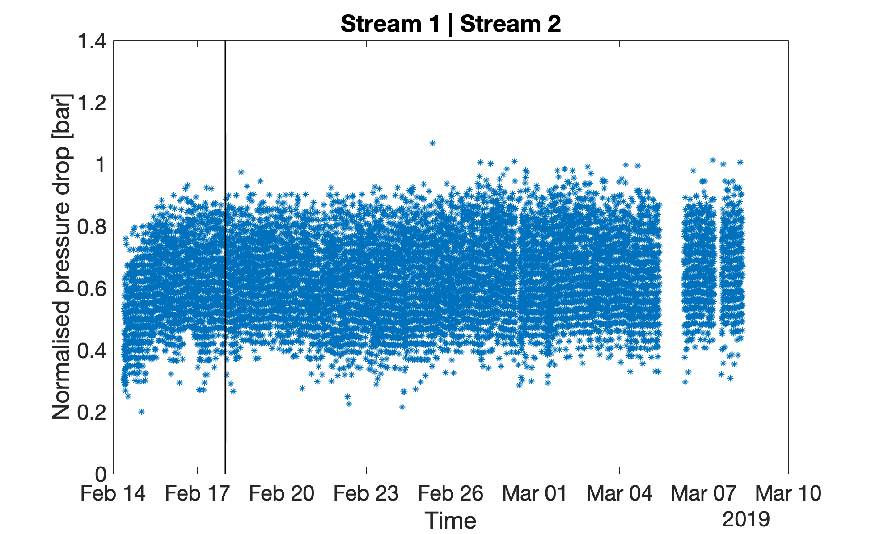  Figure 32 Normalized pressure drop of the feed channel – RO standalone on Stream 1 and 2 | 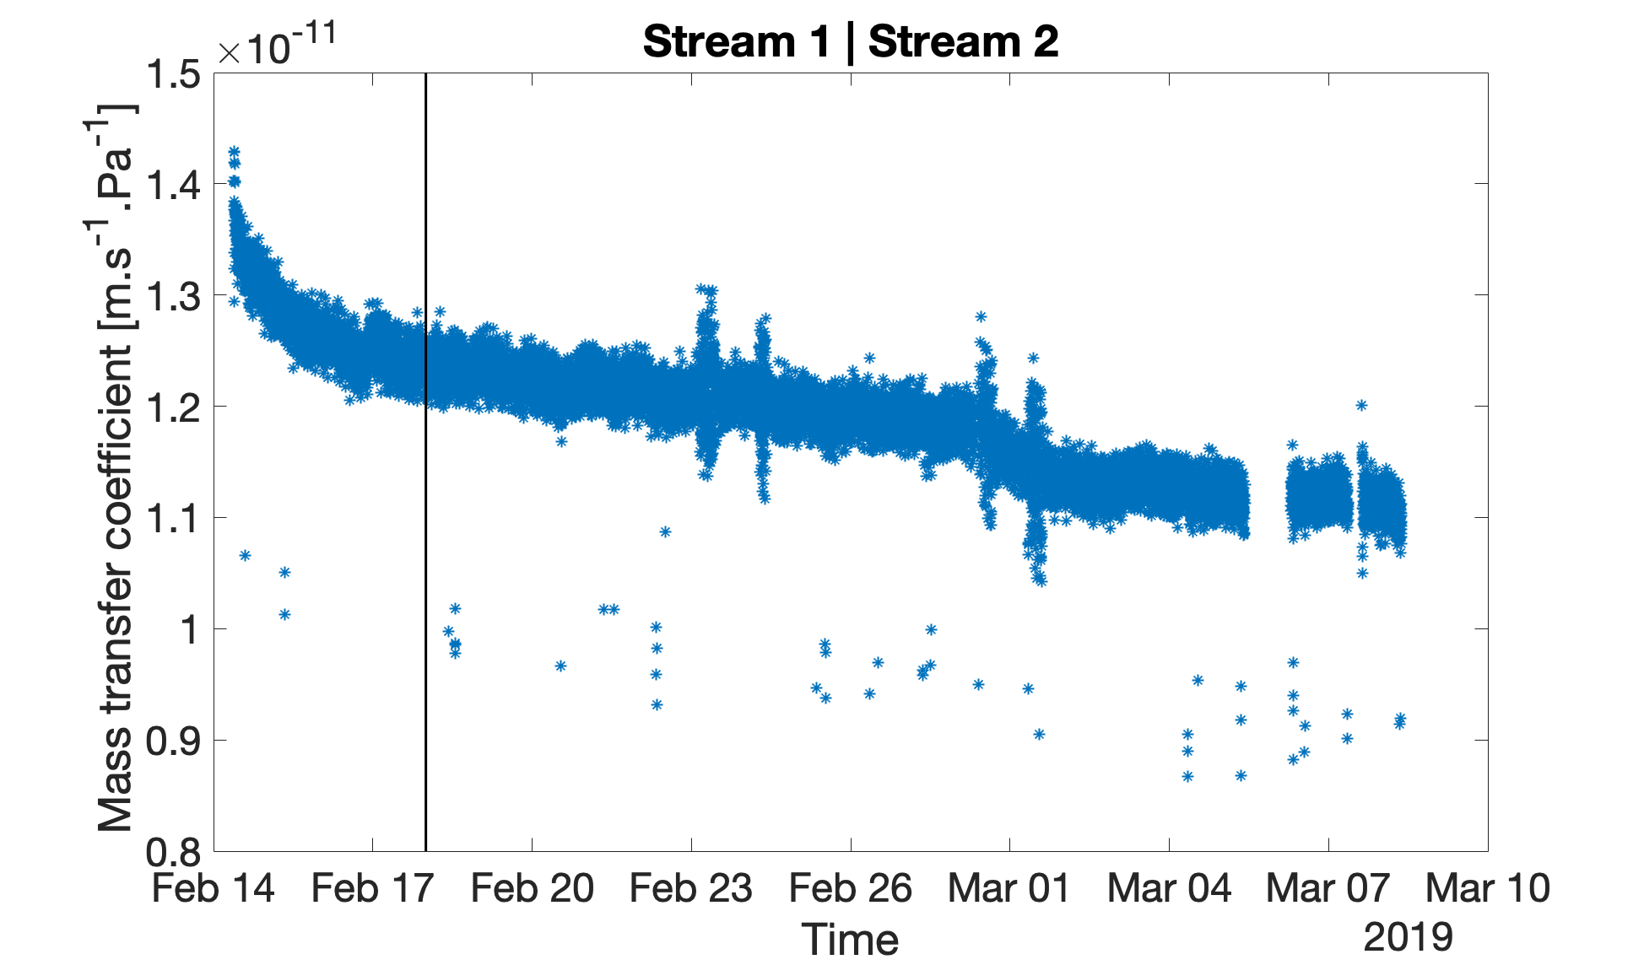  Figure 33 Normalized mass transfer coefficient - RO standalone on Stream 1 and 2

Immediately after startup, the RO increased the feed channel pressure drop from about 0.5 bar to 0.6 bar, but then remained relatively stable for the duration of the experiments with a slight increasing trend suggesting a slow fouling trend of the feed spacer. Although the spacer fouling trend is slow, it should be noted that usually the spacer channel pressure increases linearly until a certain point, followed by a rapid increase.

The mass transfer coefficient of the membrane also experienced large decrease during the first 3 days of operation, which is normal as the smallest pores quickly become blocked. From Feb 17 to Feb 28 the membrane mass transfer coefficient decreased linearly with about 8%, which is a normal rate of membrane fouling. Interestingly, immediately after the switch to Stream 2 on Feb 28th the membrane mass transfer coefficient experienced a rapid decline suggesting high fouling potential. Although before a stream change, the sampling points were thoroughly flushed at high flow rate for at least 30 minutes, the stagnant water and possibly settled rust fouled the membrane rapidly. Except for the rapid decline in the membrane performance immediately after switching streams, there is no obvious difference in the fouling potential of the two streams concerning RO.

The feed of the containers was then switched to D1 tank water. First the RO was placed behind GAC, followed by standalone operation of the RO – Figure 34 and Figure 35:

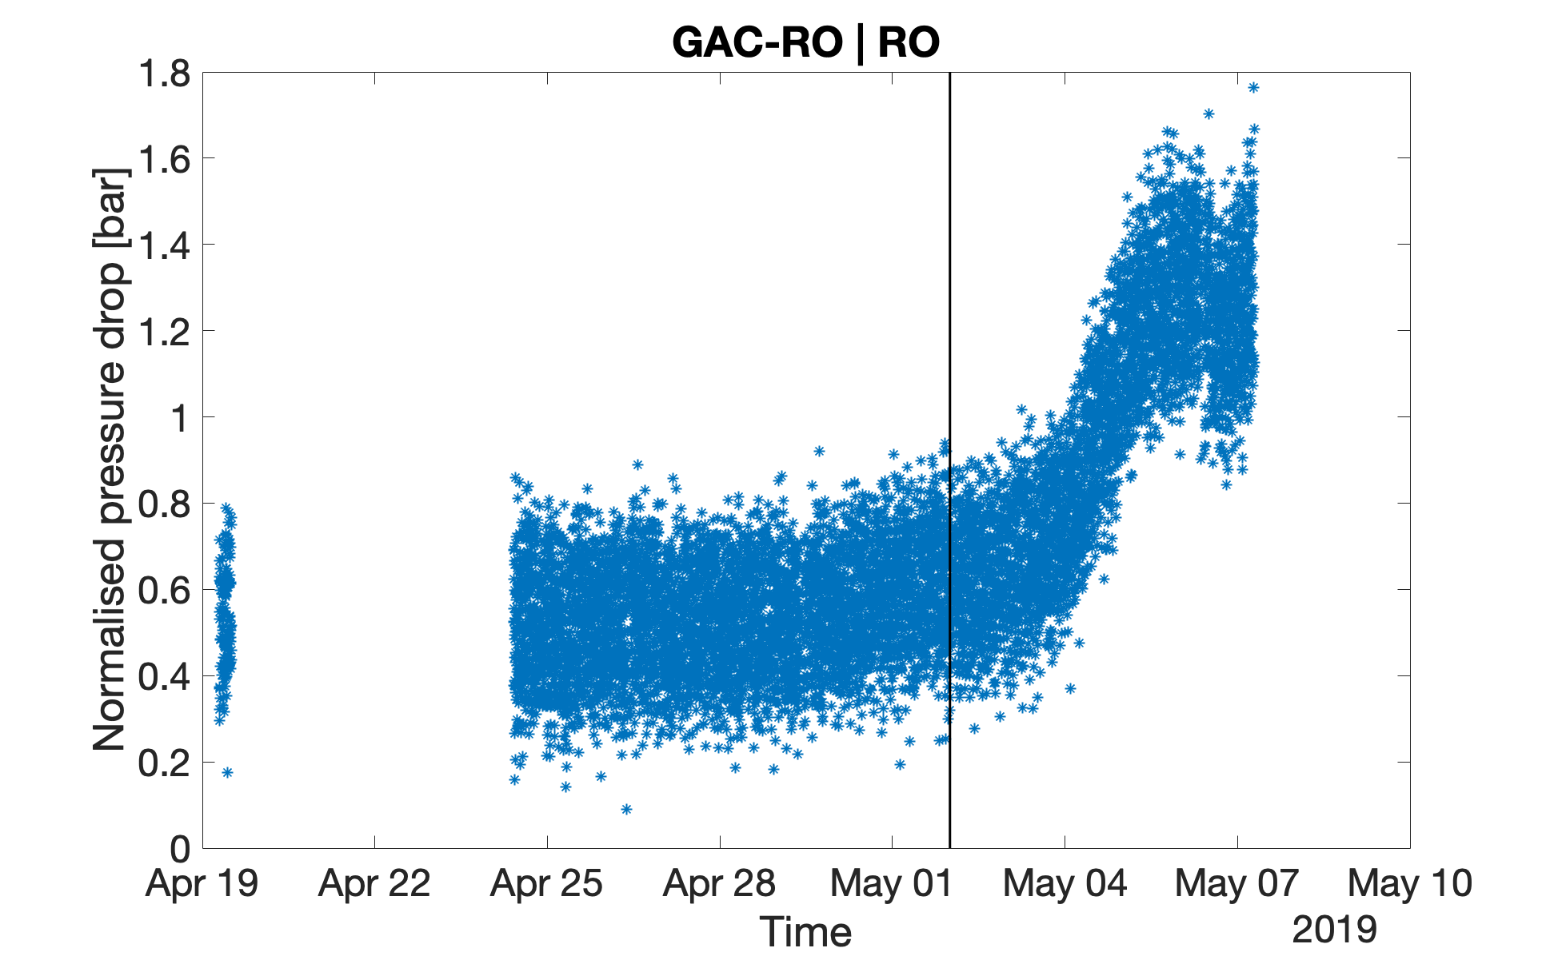  Figure 34 Normalized pressure drop of the feed channel – D1 tank water, with and without GAC pretreatment | 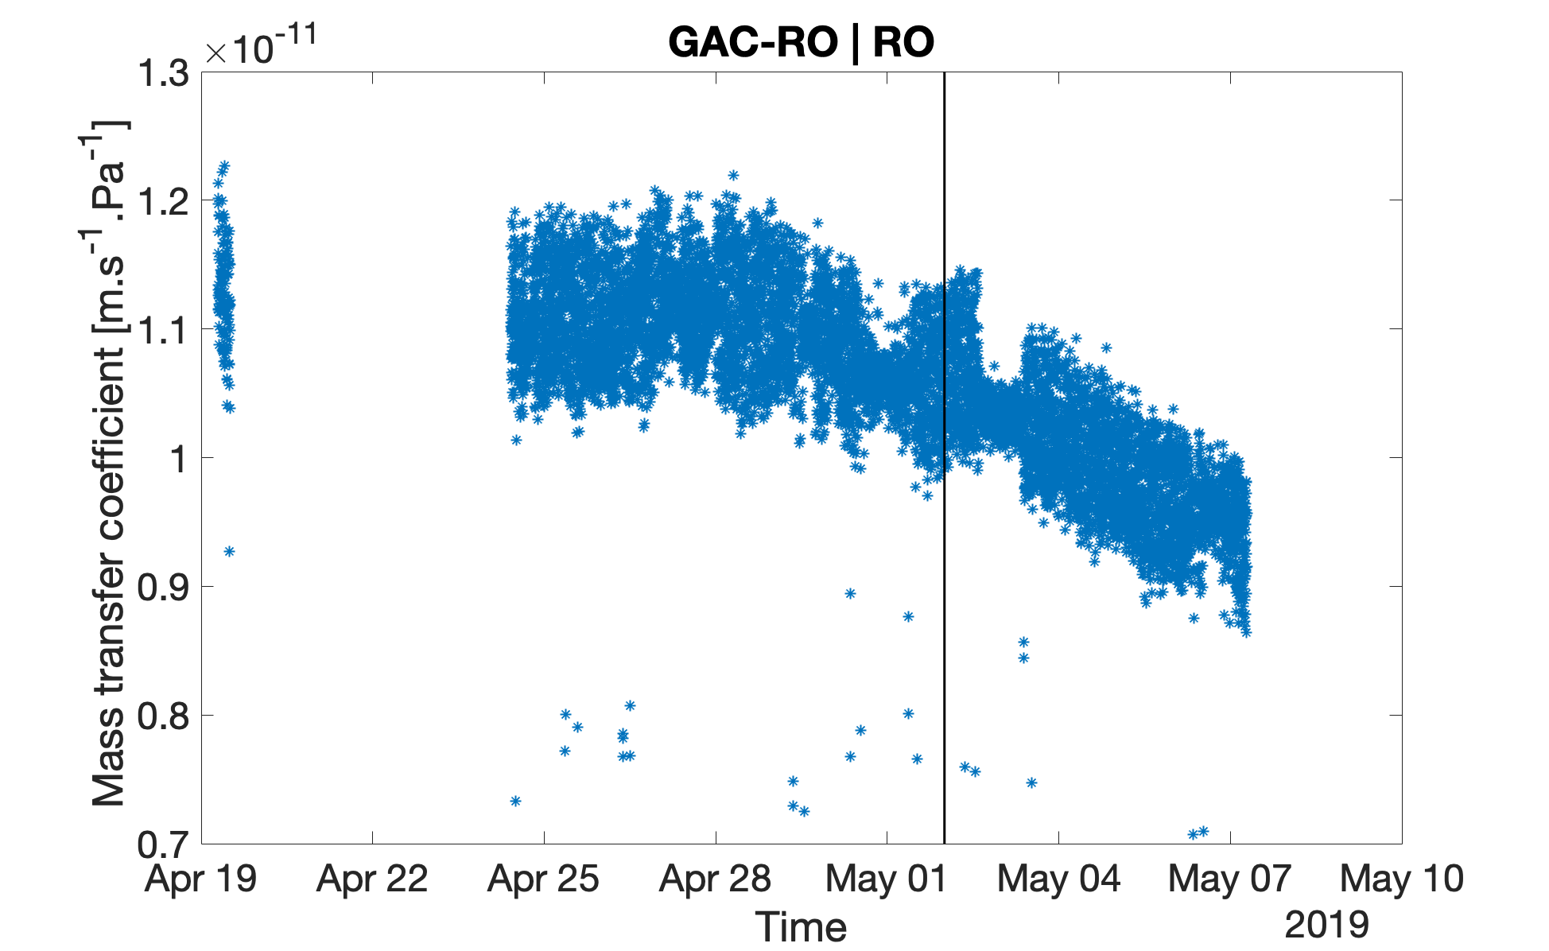  Figure 35 Normalized mass transfer coefficient– D1 tank water, with and without GAC pretreatment
When the water was pretreated with GAC the RO was working stable both in terms of feed channel pressure drop as well as mass transfer coefficient. There was a slight fouling trend in the last days of operating the GAC-RO train, but was not very conclusive. Therefore, this experiment was repeated later.

When the RO was operated without GAC pretreatment on D1 tank water, the feed channel pressure drop rapidly increased from 0.6 to 1.2 bar in only 6 days, indicating heavy spacer fouling. Similarly, the membrane mass transfer coefficient decreased from 1.075x10⁻¹¹ to 0.95 x10⁻¹¹ ms⁻¹Pa⁻¹. Overall D1 tank water proved to have a very strong fouling potential when operated on RO without pretreatment.

Since the RO was heavily fouled it was decided to do a cleaning in place. The RO buffer tank was filled with feed water and HCl. The pH was adjusted to 2 and the water was recirculated in forward flush mode (reverse to the filtration flow), returning the feed channel water to the buffer tank for 30 minutes. Then it was flushed with feed water several times until neutral pH and filled with NaOH and feed water and adjusted to pH 12. The system was recirculated for 30 minutes, then left to rest for 60 minutes, then recirculated for 15 minutes and flushed with feed water until the pH was below 10 and filtration was restarted in a SAC-MB-RO configuration.

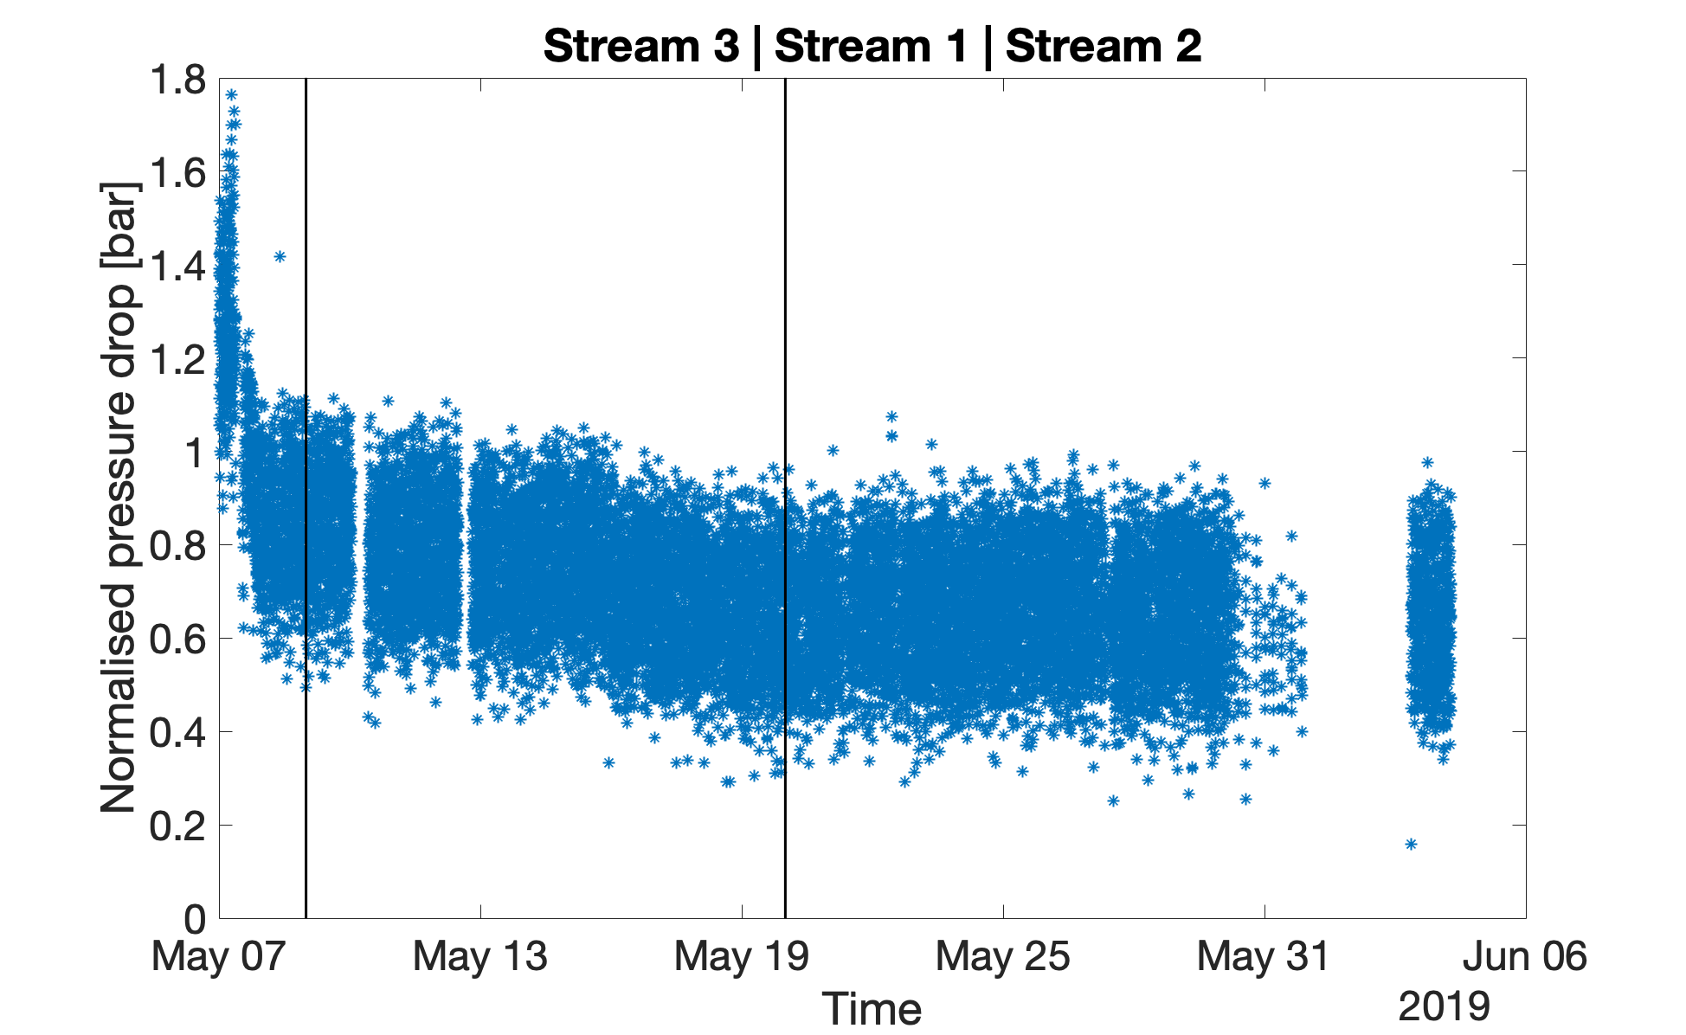  Figure 36 Normalized pressure drop of the feed channel after CIP – Streams 3, 1 and 2 in SAC-MB-RO configuration | 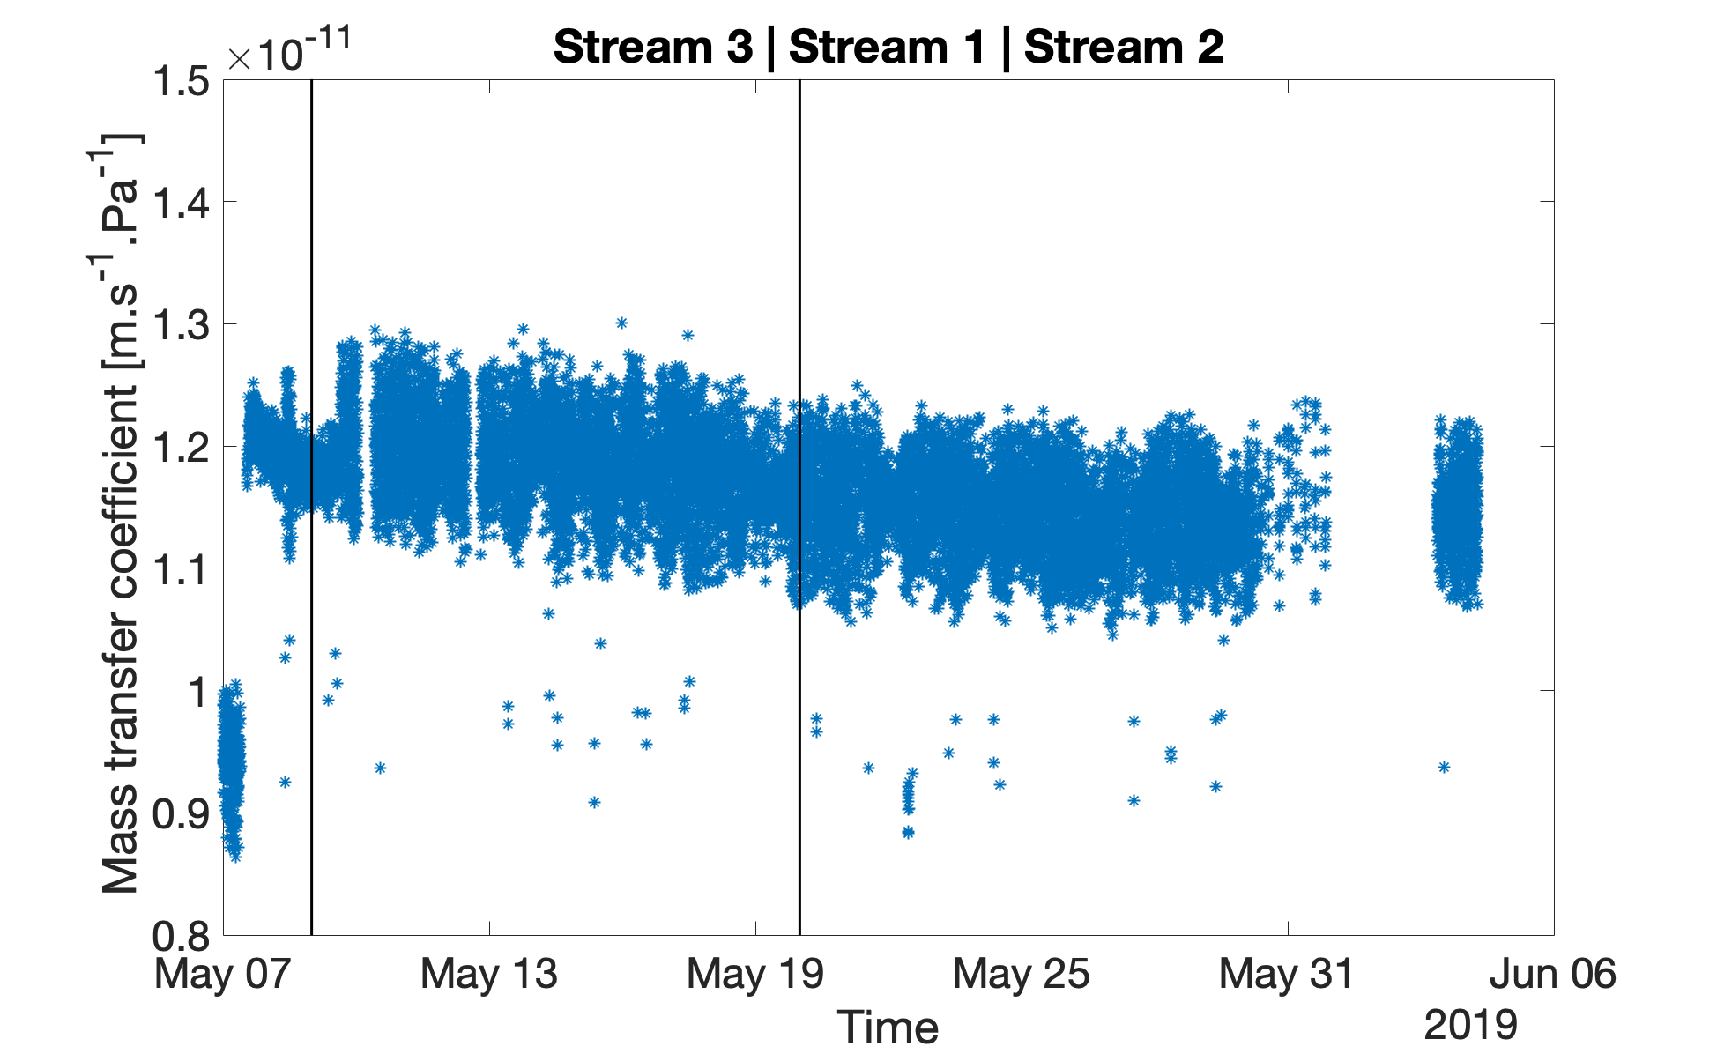  Figure 37 Normalized mass transfer coefficient after CIP – Streams 3, 1 and 2 in SAC-MB-RO configuration
The CIP had a positive effect on both the normalized feed channel pressure drop as well as on the membrane mass transfer coefficient. While the feed channel pressure drop did not decrease to the 0.5 bar value of a new module, the CIP lowered it from 1.4 to 0.8 bar. The membrane mass transfer coefficient was increased by 25%, almost to the value of a new membrane.

Running the RO behind SAC-MB was very good for the feed channel pressure drop. In fact, throughout the experiments the pressure drop slightly decreased, which can be explained by the lack of nutrients (average TOC of the SAC-MB train 377, 470 and 3587 µg/l for Streams 3, 1 and 2 respectively) and the filtration effect of the resins. It should be noted that the period of May 10 to May 27 was high TOC period for Steams 1 and 2 due to a leaking heat exchanger at Dow which allowed product to reach the condensate. While the TOC of Stream 2 was much higher than the normal feed water TOC, the majority of the high TOC load was concentrated in 2 days (22-24 May) with peak TOC in the effluent of SAC-MB of 6000 µg/l. Moreover, the TOC was of different nature than the normally occurring TOC and the microbial community did not have time to establish and form biofouling on the membrane. It is also possible that the easily degradable TOC was removed by the ion exchange resins and the remaining components were not easily biodegradable. The LC-OCD tests performed on the feed water confirmed that the unknown product is not amine, but could not identify its exact nature – Appendix A3.

The membrane mass transfer coefficient slightly decreased from by 4% for the studied period, but within normal range.

The RO was then operated on the measurement train configurations – MB-SAC-SBA-RO and MB-RO intended to study the influence of TOC on conductivity. The normalized pressure drop and mass transfer coefficient of the membrane can be seen in Figure 37 and Figure 38:
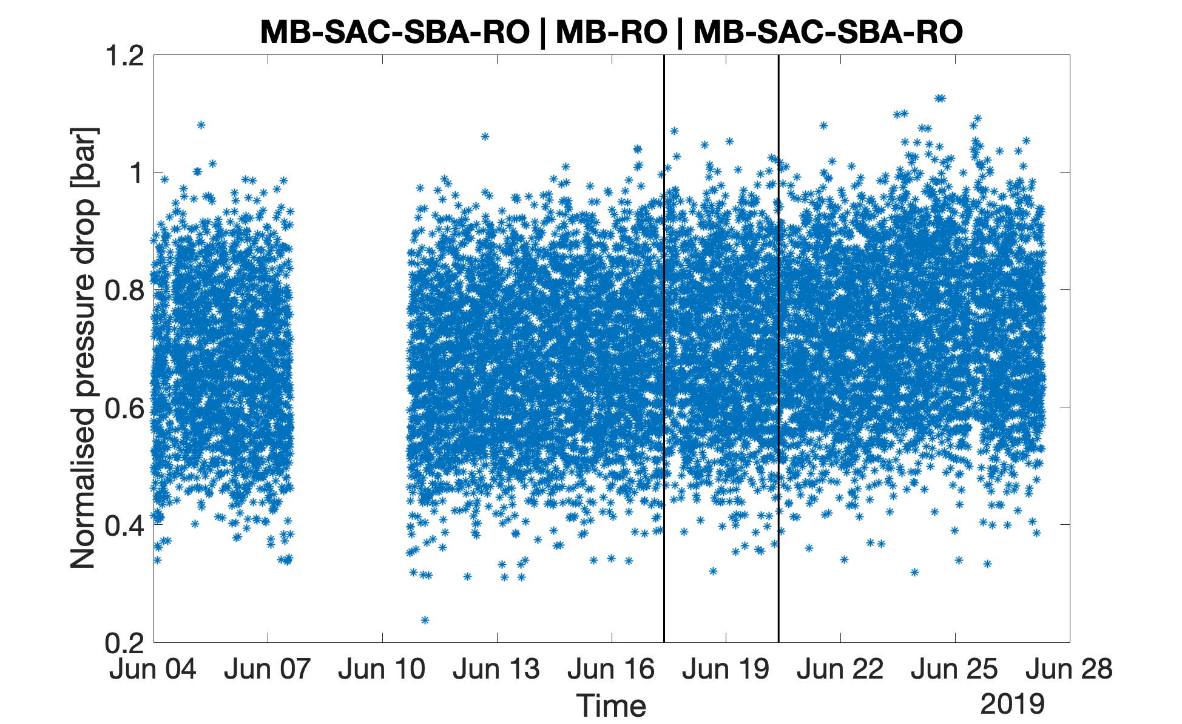  Figure 38 Normalized pressure drop of the feed channel MB-SAC-SBA-RO/MB-RO/MB-SAC-SBA-RO on Stream 1 | 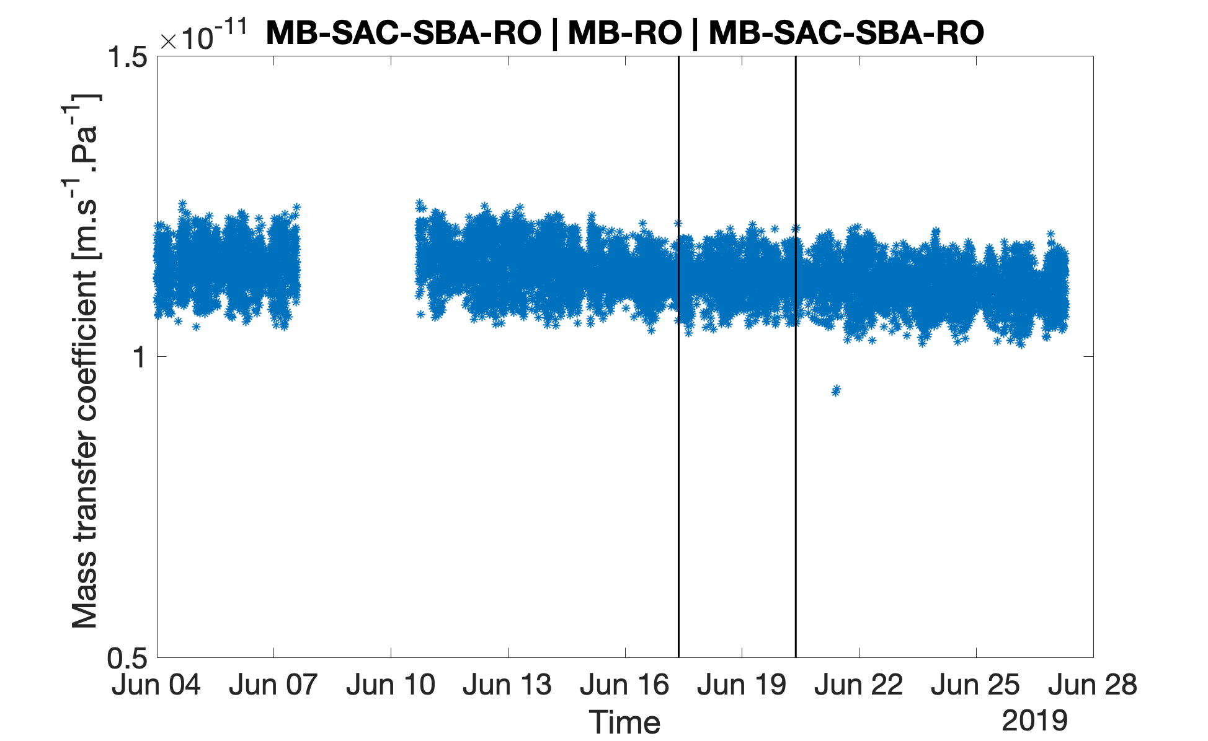  Figure 39 Normalized mass transfer coefficient MB-SAC-SBA-RO/MB-RO/MB-SAC-SBA-RO on Stream 1
The average TOC entering the RO for the three periods was 254, 121 and 178 µg/l. While this TOC was very low, still minor increase of about 0.05 bar for the feed channel pressure drop was observed, and the mass transfer coefficient of the membrane reduced by 4% for the studied period. This is acceptable over a period of 24 days.

During the final period of operation of RO, the experiments with GAC pretreatment on D1 tank water were repeated for a period of 2 weeks – Figure 40 and Figure 41:
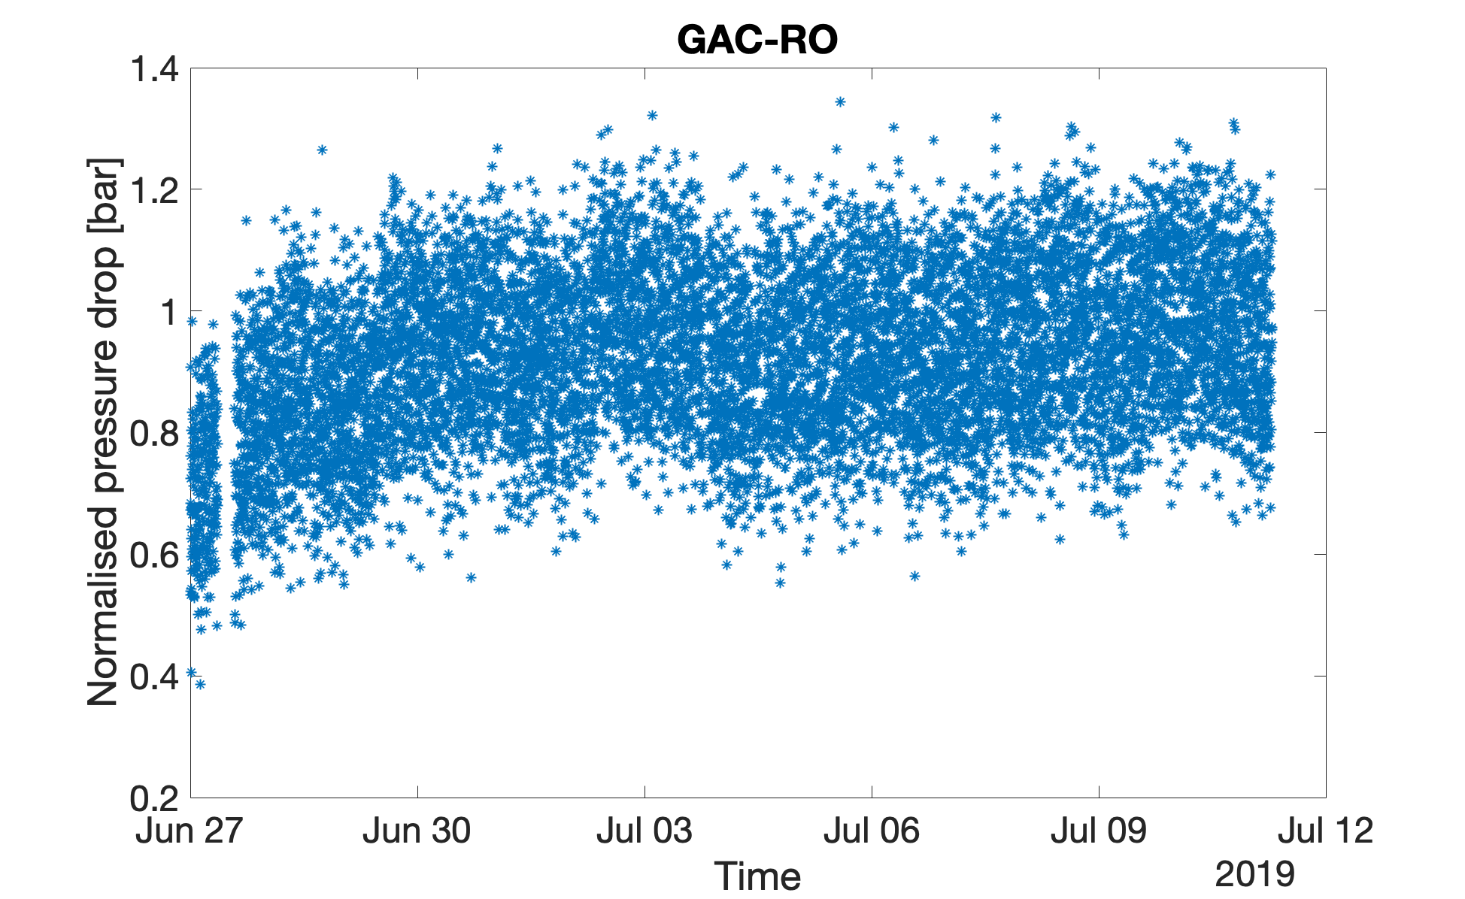  Figure 40 Normalized pressure drop of the feed channel GAC-RO on D1 tank water | 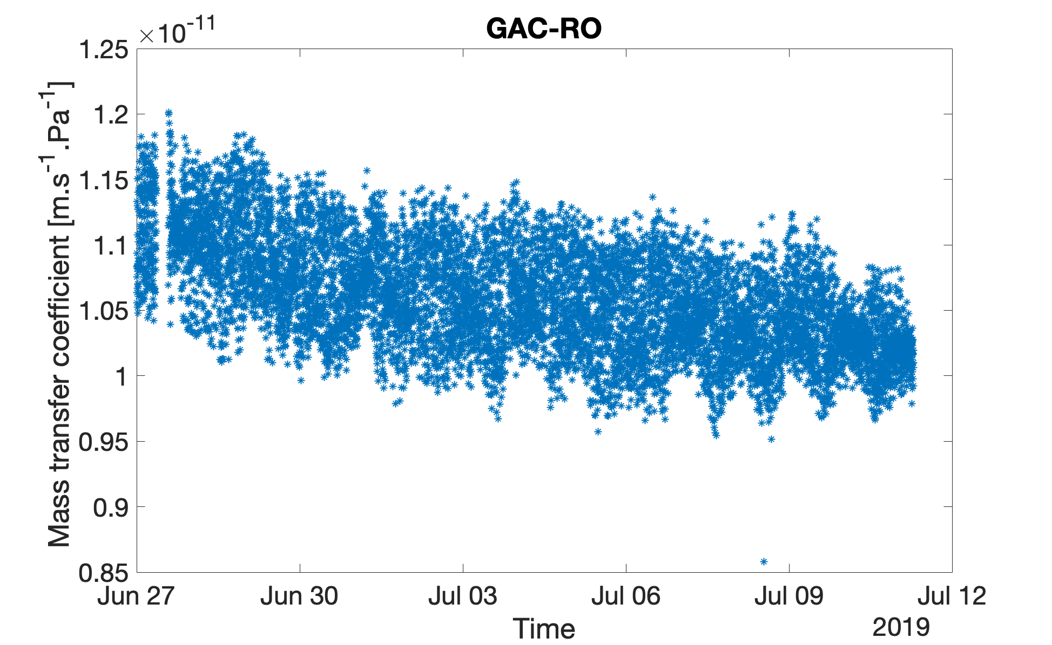  Figure 41 Normalized mass transfer coefficient MB-SAC- GAC-RO on D1 tank water

Since D1 tank water proved to be the most challenging on RO without pretreatment, the GAC-RO configuration was re-tested for a longer period of 2 weeks in order to evaluate the stability of the system. During the two weeks the pressure drop of the feed channel increased from 0.8 to 1 bar, but the pressure drop increase seems to have reached a plateau. The membrane mass transfer coefficient experienced a decline from 1.125 to 1.025 or 8%, which is acceptable for a period of 2 weeks. Overall this configuration appears to operate stable – the GAC removes the easily biodegradable components and filters the water.

Measurement train
In order to further study the influence of TOC on conductivity a measurement train was constructed MB-SAC-SBA-RO. The idea is that MB will remove most ions, the SAC and SBA will further deionize the stream by removing the positive and negatively charged ions leaving only uncharged TOC in the stream. By measuring the TOC before and after RO the influence of TOC on conductivity can be evaluated. The results of the experiment can be seen in Table 8:

Table 8 Performance of the measurement train (MB-SAC-SBA-RO) in terms of conductivity and TOC, Stream 1
Train | SC | CC | DCC | Na | Si | TOC
 | µS/cm | µS/cm | µS/cm | µg/l | µg/l | µg/l
# Samples | 21 | 21 | 21 | 8 | 8 | 21
St. Dev. | 0.003 | 0.009 | 0.007 | 0.0 | 0.3 | 16.0
Average MB | 0.070 | 0.129 | 0.100 | 0.0 | 0.9 | 184.4
# Samples | 17 | 17 | 17 |  |  | 17
St. Dev. | 0.011 | 0.016 | 0.016 |  |  | 80.0
Average SAC | 0.092 | 0.153 | 0.121 |  |  | 224.8
# Samples | 17 | 17 | 17 | 10 | 10 | 17
St. Dev. | 0.026 | 0.026 | 0.009 | 0.0 | 0.2 | 14.0
Average SBA | 0.089 | 0.159 | 0.105 | 0.1 | 0.4 | 144.9
# Samples | 21 | 21 | 21 |  |  | 21
St. Dev. | 0.017 | 0.025 | 0.007 |  |  | 8.4
Average RO | 0.702 | 0.738 | 0.088 |  |  | 34.2

To better visualize the experimental data, the conductivities as well as the TOC and the standard deviation of the measurements from the measurement train are plotted in Figure 42, Figure 43, Figure 44 and Figure 45:

Figure 42 Measurement train - Specific conductivity (SC), Stream 1, µS/cm | Figure 43 Measurement train - Cation conductivity (CC), Stream 1, µS/cm
Figure 44 Measurement train - Degassed cation conductivity (DCC), Stream 1, µS/cm | Figure 45 Measurement train - TOC Stream 1, µg/l

The specific and cation conductivities of RO are elevated due to CO2 being taken up from the atmosphere. The specific and cation conductivity increase after SAC, because the pH has decreased. Interestingly the TOC measurement of SAC was very inconsistent and would get spikes of up to 400 µg/l higher TOC than the previous technology (MB), re-sampling did not solve the problem. The origin of these TOC disturbances is unknown.

Unfortunately, there is no clear trend to identify a link between TOC and conductivity. While the TOC and DCC of RO are lower than SBA, the difference is almost within the measurement error. Considering that RO also removes some of the left-over ions, a link between DCC and TOC cannot be identified.

Amine injection experiments
In order to study the influence of the amines added to the stream on the conductivity, a blend of amines similar to the one added to the boiler feed water was prepared. A 100 ml solution was prepared containing 240 ml MEA, 240 ml 3-methoxy propylamine and 120 ml CHA, and then added to a batch of 200 L treated water. The tank was stirred using the built-in recirculation pump and the SC, CC and DCC were measured before and after the addition of amines - Table 9.

Table 9 Amine injection experiments
 | TOC, µg/l | SC, µS/cm | CC, µS/cm | DCC, µS/cm
Before injection | 35 ±5.1 | 0.718 ±0.009 | 0.777 ±0.014 | 0.099 ±0.002
After injection | 1450 ±36 | 5.210 ±0.040 | 0.851 ±0.018 | 0.135 ±0.004

The largest difference is on the specific conductivity, 3.17 µS/cm per mg/l TOC. Similar correlation can be derived for the CC (0.0525 µS/cm per mg/l TOC) and the DCC (0.0254 µS/cm per mg/l TOC), but these are less useful since it is unknown how much of the TOC is removed by the cation exchange resins and the degasser inside the instrument. One useful conclusion is that the degassed cation conductivity is very slightly affected by the injection of the amines used in the boiler feed water polishing (increase of only 0.036 µS/cm).

Pressure drop elevation on resin technologies

Pressure drop on Streams 1 and 2
For the first tests SAC-MB was tested on Stream 1 and Stream 2. The pressure increase during these periods can be seen in Figure 46 and Figure 47
Figure 46 Pressure drop of the SAC, bar. Stream 1 and 2 | Figure 47 Pressure drop of the MB, bar. Stream 1 and 2

The main pressure drop was exhibited by the SAC resins. In both streams the SAC resin pressure drop increased by about 0.5-0.6 bar in 5 days of operation. Interestingly the pressure drop of the MB increased only on Stream 1 and remained constant on Stream 2, however Stream 1 was tested for a two times longer period and possibly the same trend would be observed if Stream 2 was tested for a longer period.

Rust particles were observed in both streams – Figure 48 and Figure 49
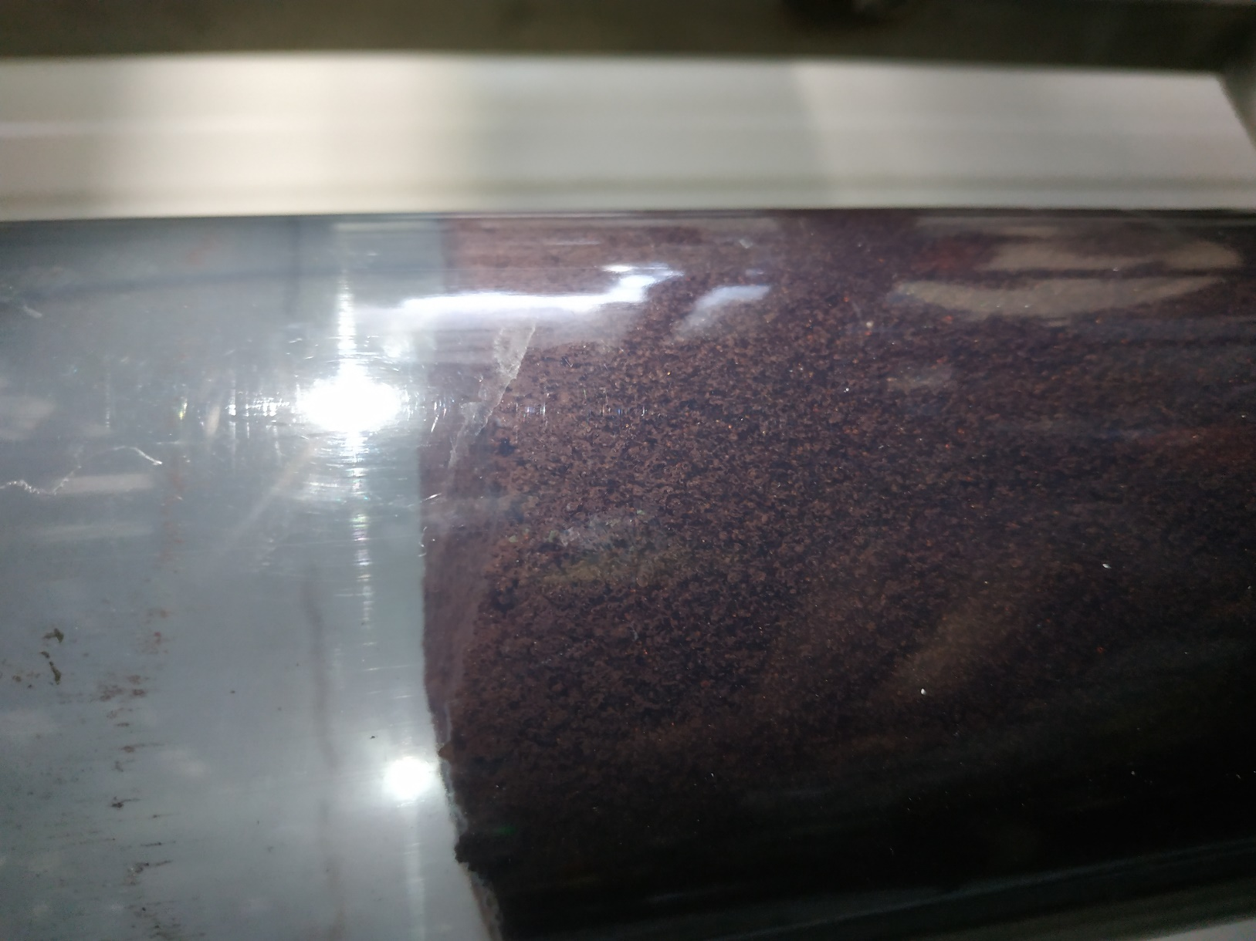  Figure 48 Rust particles settled on top of the SAC column | 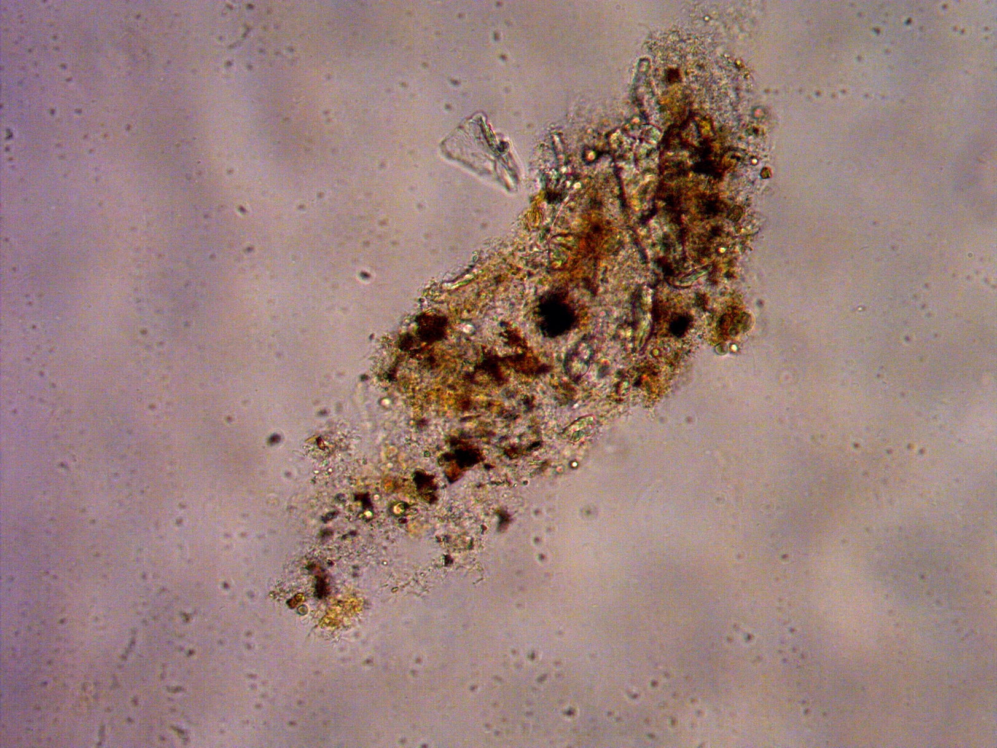  Figure 49 Optical microscopy of the rust particles (Stream 1)

The rust particles also seem to form bacterial flocks around them as seen in Figure 49. Iron is known to cause problems with biofouling since it would promote the development of iron oxidizing bacteria in oxygen rich conditions and iron reducing bacteria in oxygen deprived areas. Since the IEX and mix tank pumps add a lot of oxygen as seen in Section 4.4, the bacteria should be of the first type.

A test with a MB was performed on Stream 1

Similarly to the SAC-MB case the major pressure drop was exhibited in the first days of operation followed by a plateau in the pressure drop.

Pressure drop on SAC-MB on D1 tank water

Figure 50 Pressure drop of SAC-MB on D1 tank water

The fouling on D1 tank water was much more intense compared to the other streams. In only 7 days of operation the maximum pressure of the system was reached. Throughout the operation the SAC was backwashed with water and air injection from the bottom of the columns. The air injection introduces bubbles that help to fluidize the resins and this strategy was very successful during the first two backwash cycles – the pressure of the system returned to the initial values. However, as time progressed the backwashing needed to happen more frequent to the point where the system would not be able to operate overnight and was stopped on May 10th. It should be noted that the system was started with a brand-new SAC resins and on the 8th day of operation the MB were replaced as well. The backwash with air scouring performed very well during the first cycles, releasing very turbid backwash water. With each following backwash cycle, the backwash water gradually became clearer and the effect of backwashing less pronounced. This was attributed to the biofouling gradually developing on the resins and holding them down, preventing fluidization. It should be noted that the resin columns inside the improved containers are very narrow (10 cm internal diameter) and long (136 cm). This makes it very hard for the resin to fluidize. A full scale-installation should be built with a much smaller length to width ratio and a lot of headspace to be able to fluidize the resins and make the backwashing more effective.

The experiments with SAC-MB on D1 tank water were performed again, this time with a limited DO in the stream. In order to limit the DO, the mixing tank was completely bypassed and the recirculation of the IEX feed pump recirculation was disabled. This limited the usual DO of the SAC feed from 6.8-7.5 mg/l to 2.3-3.6 mg/l. The resulting behavior can be seen in Figure 51

Figure 51 Pressure drop of the SAC-MB with limited DO. D1 tank water

Overall there is no significant difference in the pressure drop increase with and without limiting the intake of DO. In both cases the pressure drop reaches its maximum within 8 days of operation. On July 6th the SAC was regenerated and the experimers were performed again, yielding similar results. It should be pointed out that the experiments without limiting the DO were performed with fresh SAC resin, while the limited DO experiments were performed with SAC that was only regenerated and might have some residual fouling left.

Economic evaluation
For each technology the cost for maintenance was assumed to be 3% of the total investment per year. Excluded costs are engineering costs, hours for building, raw water, discharge, permits and inspection, risk and profits, sampling and analyses, man hours for operation and redundancy. The maintenance is considered as 3% of the initial investment per year. The overall accuracy of the economic evaluating is expected to be within ±50%.

The economic analysis was done, based on general (DACE) cost engineering indicators Scaling-up the RO and IEX can be done with more confidence compared to the other more novel techniques such as GAC pretreated trains. The usage of chemicals can differ significantly on full-scale.

This economic analysis should be considered as a techno-economic feasibility study and not as prices for a full-scale installation. There are many exclusions and assumptions involved in the economic evaluation that can easily double the predicted CapEx when included in the calculation.

The CapEx and OpEx were calculated based on the combined flow rates of all three streams currently going to the D1 tank (order of 500 t/h). During the testing period the following operational parameters of the different technologies were observed and used as a basis for the economic analysis Table 10.

Table 10 Specific energy consumption and recovery used as basis for the economic evaluation
 | SEC (kWh/m³) | Recovery (%)
GAC | 0.017 | 98
SAC | 0.034 | 99
MB | 0.034 | 99
RO | 0.358 | 85

Based on these number the economic evaluation for the three cases – MB, SAC-MB and GAC-RO-MB was calculated - Table 11.
Table 11 Economic evaluation of the three cases
Tested technologies |  | OpEx  €/year | CapEx  €
 | Case 1 | € 149,729.89 | € 578,500.00
 | Mixed Bed | € 149,729.89 | € 578,500.00
 | Case 2 | € 148,055.68 | € 1,046,957.50
 | Strong Acid Cation | € 37,398.39 | € 468,457.50
 | Mixed Bed | € 110,657.29 | € 578,500.00
 | Case 3 | € 424,731.52 | € 1,969,061.97
 | Granular Activated Carbon | € 80,876.82 | € 472,861.97
 | Reverse osmosis | € 241,463.00 | € 927,700.00
 | Mixed Bed | € 102,391.69 | € 568,500.00

The MB which is the current technology is the cheapest alternative to treat the condensate streams. This technological train also exhibits very good permeate quality in terms of conductivity, but somewhat elevated TOC levels.

The SAC-MB train does not improve the conductivity of the produced water but can solve the problems with increased pressure drop of the resins, since the SAC can be backwashed while the MB can remain operational until it’s capacity is exhausted. The TOC obtained by SAC-MB and MB is the same in most of the tests. While the OpEx for the two technological trains is similar, the CapEx is logically doubled due to the extra SAC unit.

The GAC-RO-MB train is the most expensive case both in terms of OpEx and CapEx. However, this case performs very well in terms of conductivity (30-40% lower than the SAC-MB). Another advantage is the extremely low TOC level, which is beneficial both for lowering the corrosion as well as eliminating the biological growth in the distribution network. Therefore, the choice between SAC-MB and the GAC-RO-MB should be made considering the maintenance costs of the steam cycle network of the plant.

Conclusions
Overall the condensate streams proved to be very challenging to treat due to biofouling and large percentage of low molecular weight neutrals forming the TOC which is hard to remove with ion exchange process. Throughout the testing it was discovered that the D1 tank water which is a mixture of three condensate streams and demin was the hardest to treat in terms of fouling and shows that the current storage of the condensates is detrimental for the fouling due to intrusion of DO from the headspace of the tank as well as additional rust coming from this tank. A nitrogen blanket on this tank would help limit the biological development and rust inside.

Out of the treatment options 3 major configurations can be considered for future implementation – MB, SAC-MB and GAC-RO-MB, listed in increasing order of capital investment cost. The quality of MB and SAC-MB is comparable, but the SAC-MB is more robust since the SAC can be backwashed and placed back in operation, while the MB can continue to produce good quality water. The GAC-RO-MB is twice as expensive compared to SAC-MB but has several significant advantages in terms of quality. The GAC-RO-MB option produces 30% lower degassed cation conductivity and more than 30 times lower TOC values. This directly correlates to lower corrosion in the steam cycle network and lower maintenance cost. Moreover, the GAC-RO-MB reduces the bacteria 3 orders of magnitude and the remaining bacteria are 0 percent active with little to no nutrients for the biology to re-develop.

Acknowledgments
The authors would like to thank the laboratory personnel of Dow and the operations of Power and Utilities for the professionalism and hard work during the project. The authors are grateful to Sara Vernimmen for the warm welcome and help with setting up the container at Dow. Special thanks go to Bram and Han for taking excellent care of the IMPROVED containers as secondary operators. Finally, the authors are grateful to Niek Van Belzen and Niels Groot for being excellent hosts on Dow side.

References

[1] | S. w. t. a. solutions, " Handbook of Industrial Water Treatment," [Online]. Available: https://www.suezwatertechnologies.com/handbook/chapter-19-condensate-system-corrosion#EFFECT%20OF%20pH%20ON%20CORROSION%20OF%20IRON%20AND%20COPPER.
[2] | B. Malfroot, "Lab-scale and pilot-scale investigation of condensate polishin units," UGent, 2019.
[3] | D. W. Solutions, "https://water.custhelp.com," Dupont, [Online]. Available: https://water.custhelp.com/app/answers/detail/a_id/4219/~/dow-water-and-process-solutions_-correlation-between-kmno4,-cod,-bod,-doc.
[4] | H. Huiting, M. de Koning and E. F. Beerendonk, "Normalisatie van gegevens bij nanofiltratie en omgekeerde osmose," KIWA-VEWIN SWI 199.66, 1999.
[5] | A. E.-G. K. E.-Z. Heba ABDALLAH, "Hydrophobic polyethersulfone porous membranes for membrane distillation," Frontiers of chemical science and engineering, pp. 84-93, 2015.
[6] | Lenntech, "Hydranautics, RO water chemistry," 09 01 2019. [Online]. Available: https://www.lenntech.com/Data-sheets/Hydranautics-RO-Water-Chemistry-LL.pdf. [Accessed 09 01 2019].
[7] | N. S. ALZAFIRI, "The effectiveness of antiscalants when used on multistage flash distillers (Doctoral thesis)".
[8] | K. D. D. a. A. Ketsetzi, "Degradation of Phosphonate-Based Scale Inhibitor Additives in the Presence of Oxidizing Biocides: “Collateral Damages” in Industrial Water Systems," Separation Science and Technology, vol. 42, pp. 1639-1649, 2007.
[9] | H. Strathmann, "Electrodialysis," Encyclopedia of Membranes, 2016.
[10] | I. Hitsov, L. Eykens, W. D. Schepper, K. D. Sitter, C. Dotremont and I. Nopens, "Full-scale direct contact membrane distillation (DCMD) model including membrane compaction effects," Journal of Membrane Science, vol. 524, pp. 245-256, 2017.
[11] | P. M. /. R. T. I. IWC-99-64, "BEHAVIOR OF SILICA IN ION EXCHANGE AND OTHER SYSTEMS," [Online]. Available: https://snowpure.com/docs/resintech-silica-iwc99.pdf. [Accessed 31 01 2019].
[12] | S. Derese, Towards innovative technologies for nutrient recovery from human urine, Doctoral Thesis, UGent, 2018.
[13] | T. V. Overstraeten, "Water reuse and alternative water sources," Ghent University, Ghent, 2018.

List of abbreviations
AEM |  | Anion exchange membrane
CapEx |  | Capital Expenditure
CC |  | Cation conductivity
CHA |  | Cyclohexyl amine
CIP |  | Cleaning in place
COD |  | Chemical oxygen demand
DCC |  | Degassed cation conductivity
Deg |  | Degasser
DO |  | Dissolved oxygen
EDR |  | Electrodialysis reversal
FC |  | Flow cytometry
GAC |  | Granular activated carbon
IC |  | Inorganic carbon, ion chromatography
IEX |  | Ion exchange
IMPROVED |  | Integrale Mobiele PROceswater Voorziening voor een Economische Delta
IPA |  | Isopropyl alcohol
LC-OCD |  | Liquid chromatography - organic carbon detection
MB |  | Mixed bed resin
MEA |  | Monoethanol amine
MTC |  | Mass transfer coefficient
NSP |  | Normalized salt passage
OpEx |  | Operational Expenditure
RO |  | Reverse osmosis
SAC |  | Strong acid cation exchange resin
SBA |  | Strong base anion exchange resin
SC |  | Specific conductivity
TC |  | Total Carbon
TOC |  | Total organic carbon
WAC |  | Weak acid cation exchange resin
WBA |  | Weak base anion exchange resin

Appendices

A.1 LC-OCD test 22 Feb and 15 March - Stream 1
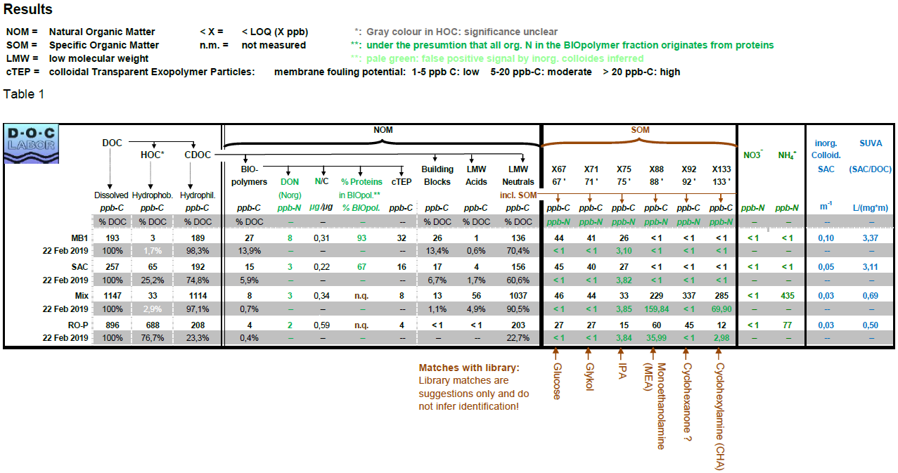
*X92 Cyclohexanone is probably 3-Methoxypropyl amine
Figure 52 Stream 1 LC-OCD MB, SAC, Mixing tank, RO permeate - 22 Feb. Trains: RO / SAC-MB1
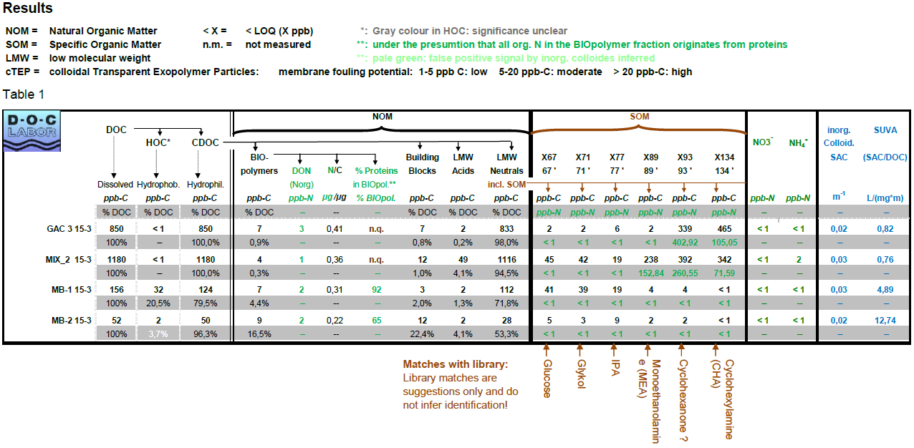
*X93 Cyclohexanone is probably 3-Methoxypropyl amine
Figure 53 Stream 1 LC-OCD GAC3, Mixing tank, MB1 and MB2 - 15 March. Trains: MB1 / GAC-MB2. The GAC still has residual absorption capacity (4th day of operation), but the removal efficiency based on TOC is greatly decreased from 90.4% in day 1 to 33.1%.

A.2 LC-OCD test 4 March and 5 Apr - Stream 2

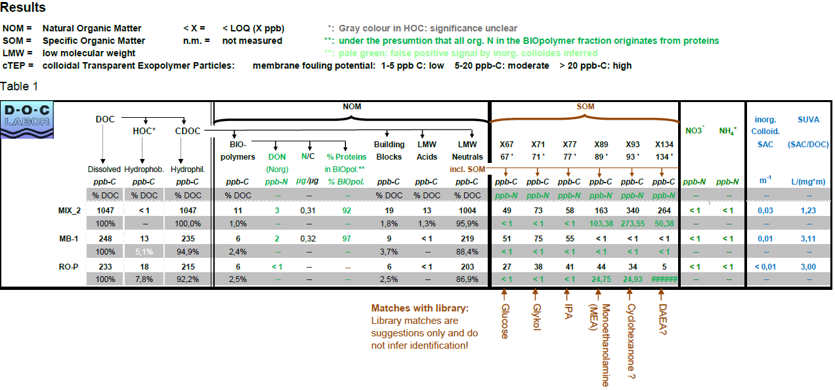
*X134 DAEA could also be cyclohexylamine. The latter is more likely as it is a known added amine
**X93 Cyclohexanone is probably 3-Methoxypropyl amine
Figure 54 Stream 2 LC-OCD test Mixing tank, MB and RO permeate - 4 March. Trains: RO / SAC-MB1

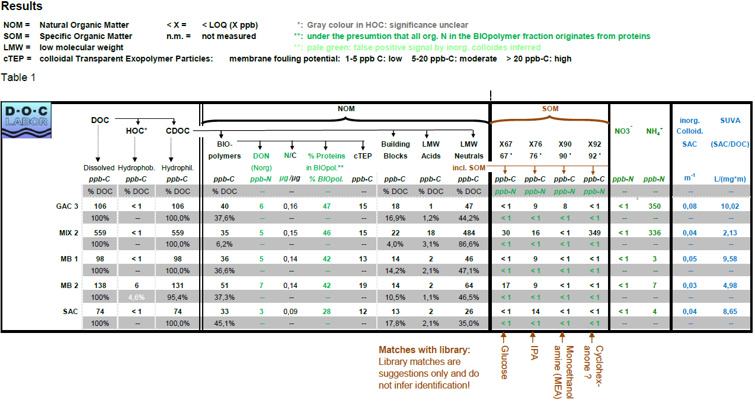
*X92 Cyclohexanone is probably 3-Methoxypropyl amine
Figure 55 Stream 2 LC-OCD test GAC3, Mixing tank, Mixed bed 1, Mixed bed 2 and SAC - 5 April. Trains: MB2 / GAC-SAC-Deg-MB1

A.3 LC-OCD test D1 tank water; High TOC period for Streams 1 and 2
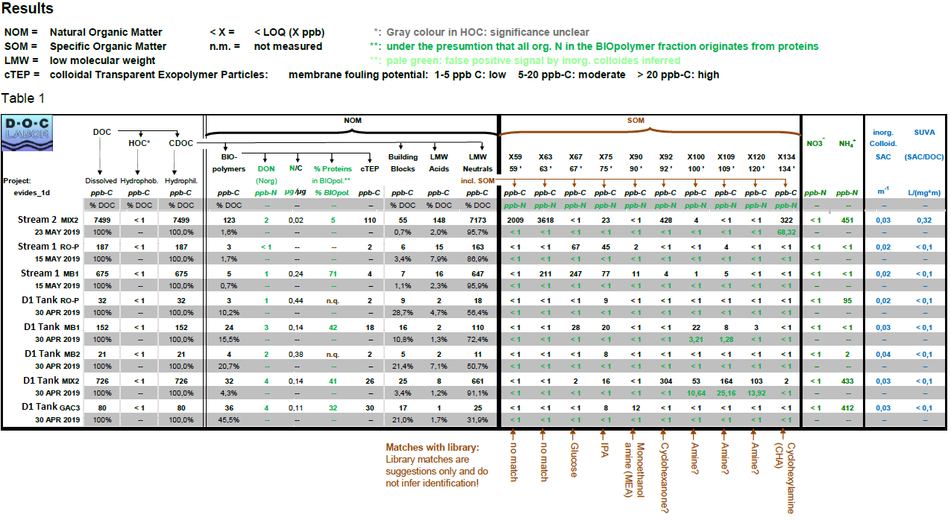
Figure 56 LC-OCD test of High TOC for streams 1 and 2. Normal TOC test for D1 tank water. The vial for Mixing tank of Stream 1 was broken during shipping. Stream 1 train SAC-MB1-RO. Stream 2 train – only mixing tank sampled. D1 tank water trains: GAC-RO-MB2 / SAC-MB1.

A.4 Used equations
$$SP={EC}_{p}×T_{cf_EC}×Q_{cf}$$

$${EC}_{p}=100×\frac{{EC}_{permeate}}{({EC}_{feed}×\left(log\frac{1}{1-Recovery}\right))/Recovery}$$

$$T_{cf}=\exp^{(U_{par}×\left(\left(\frac{1}{T_{feed}+273.15}\right)-\left(\frac{1}{T_{ref}+273.15}\right)\right))}$$

Where $U_{par}$ is the Dow membrane U-value, equal to 3200, ${EC}_{p}$ is the recovery corrected permeate conductivity, $T_{ref}$ is the reference temperature equal to 25 ºC and $T_{cf}$ is the conductivity corrected temperature.

$$NPD=dP×Q_{cf}×T_{cf}$$

$$dP=P_{feed}-P_{concentrate}$$

$$Q_{cf}={(\frac{Q_{vc}}{\frac{Q_{permeate}+Q_{concentrate}}{2}})}^{m}$$

$$Q_{vc}=\frac{Q_{feedn}+Q_{concentraten}}{2}$$

$$T_{cf}={(\frac{η_{ref}}{η_{feed}})}^{n}$$

Where NPD is normalized pressure drop [kPa], $Q_{feedn}$ normalized design feed flow of the RO system [m³.h⁻¹], $Q_{concentraten}$ normalized design concentrate flow [m³.h⁻¹], $T_{cf}$ is the viscosity corrected temperature, $Q_{vc}$is the viscosity corrected flow, $η_{ref }$and $η_{feed}$ are reference and feed viscosity respectively, m and n are Dow membrane values, equal to 1.6 and 0.4, respectively.

$$MTC=\frac{Q_{permeate}×T_{cf}×{10}^{-5}}{36×Q_{pemeate}}$$

$$NDP=((\frac{P_{feed}+P_{concentrate}}{2}-P_{permeate})×100)-(\frac{{OP}_{feed}+{OP}_{concentrate}}{2}-{OP}_{permeate})$$

$$T_{cf_OP}=\frac{T_{feed}+273.15}{T_{ref}+273.15}$$

$${OP}_{feed}={EC}_{feed}×{EC}_{OP_feed}×T_{cf_OP}$$

$${OP}_{concentrate}={EC}_{concentrate}×{EC}_{OP_concentrate}×T_{cf_OP}$$

$${OP}_{permeate}={EC}_{permeate}×{EC}_{permeate}×T_{cf_OP}$$

Where MTC is the mass transfer coefficient [m.S⁻¹.Pa⁻¹], NDP net driving pressure [kPa], OP osmotic pressure calculated for feed, permeate and concentrate [kPa] and $T_{cf_OP}$ is the osmotic pressure corrected temperature.

A.5 Principle of flow cytometry analyses

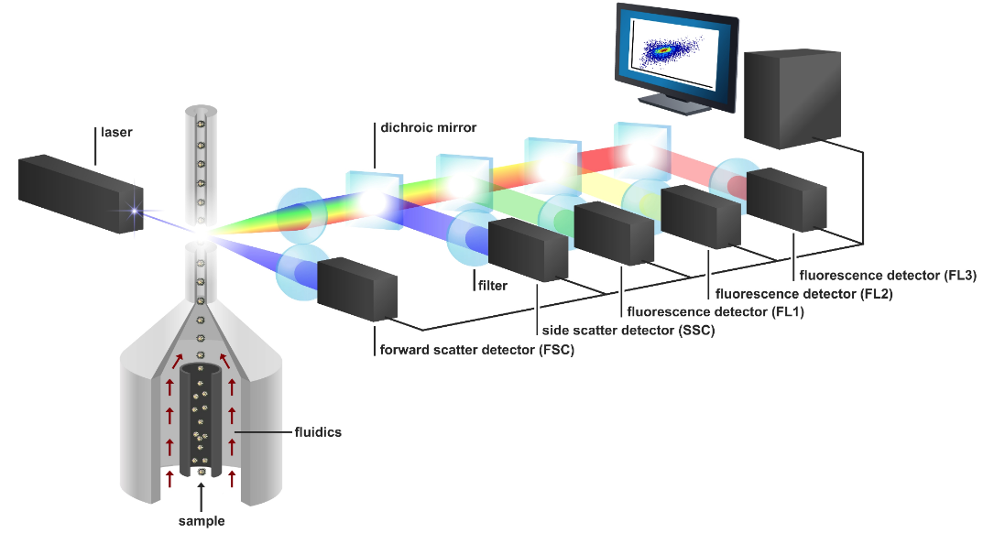
Figure 57 The principle of flow cytometry. A sample is aligned by the sheath fluid (Milli-Q) and is sent through the laser [5]. The scatter and fluorescence signals emitted by each particle are detected by six separate detectors and the signal is sent to the computer. The output is a “fingerprint” of all particles detected, which looks like a cloud, in which each dot represents a particle.
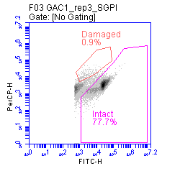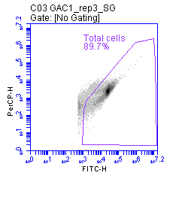
Figure 58 An example of the plot generated by flow cytometric analysis, with separation of the background and the cells of interest through gating. This plot shows the green fluorescence (FITC-H) in function of the red fluorescence (PerCP-H), as these are the channels that are triggered by SG and PI respectively. A threshold is put on 500 for the green fluorescence channel signal height. Left: SGPI-stained sample, which allows discrimination between intact and damaged cells, right: same sample, but with SG staining for the determination of the total cell concentration.

